现在，我们以上次部署的区块链及WeBase为基础，开始讲解本次内容：

本次实验分为两部分，第一步分为智能合约的部署，第二部分为使用FISCO提供的Java SDK与链进行交互。

注意：每步操作请先看描述，按照步骤执行，然后与示意图对比，结果一样即为操作成功，结果不同请按步骤重试

**一．智能合约部署**

1. 启动区块链
2. 切换目录（注意，初始目录应为：~/）

cd fisco/

1. 启动链

bash nodes/127.0.0.1/start_all.sh

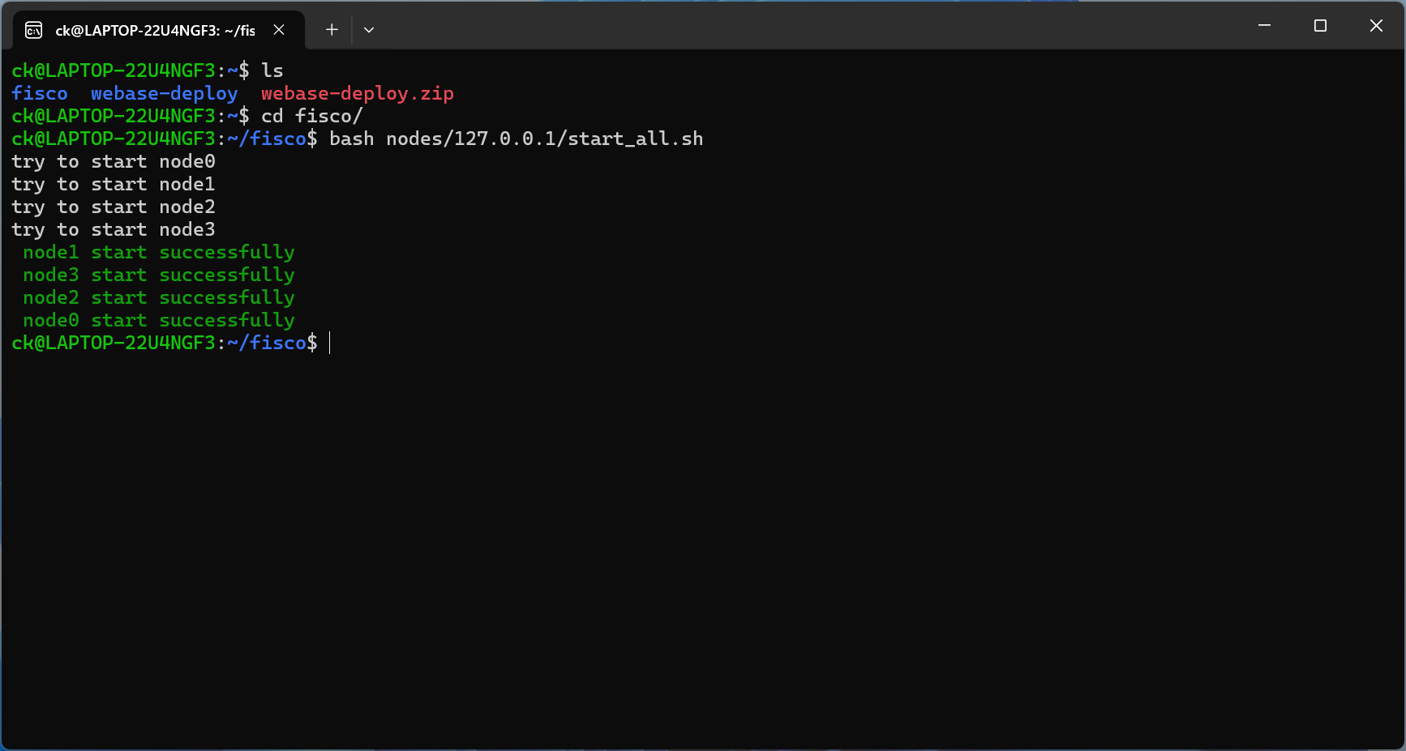

1. 启动WeBase
2. 切换目录

cd webase-deploy/

1. 启动WeBase

python3 deploy.py startDockerAll

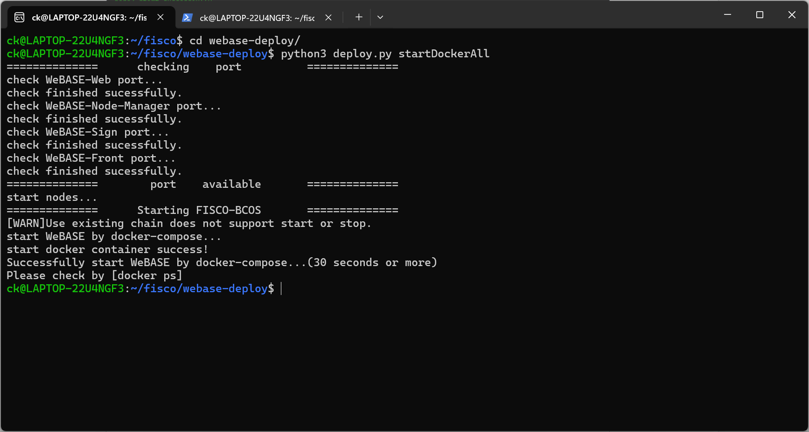

3部署智能合约

1. 使用浏览器登录WeBase

<http://localhost:5000/#/login>

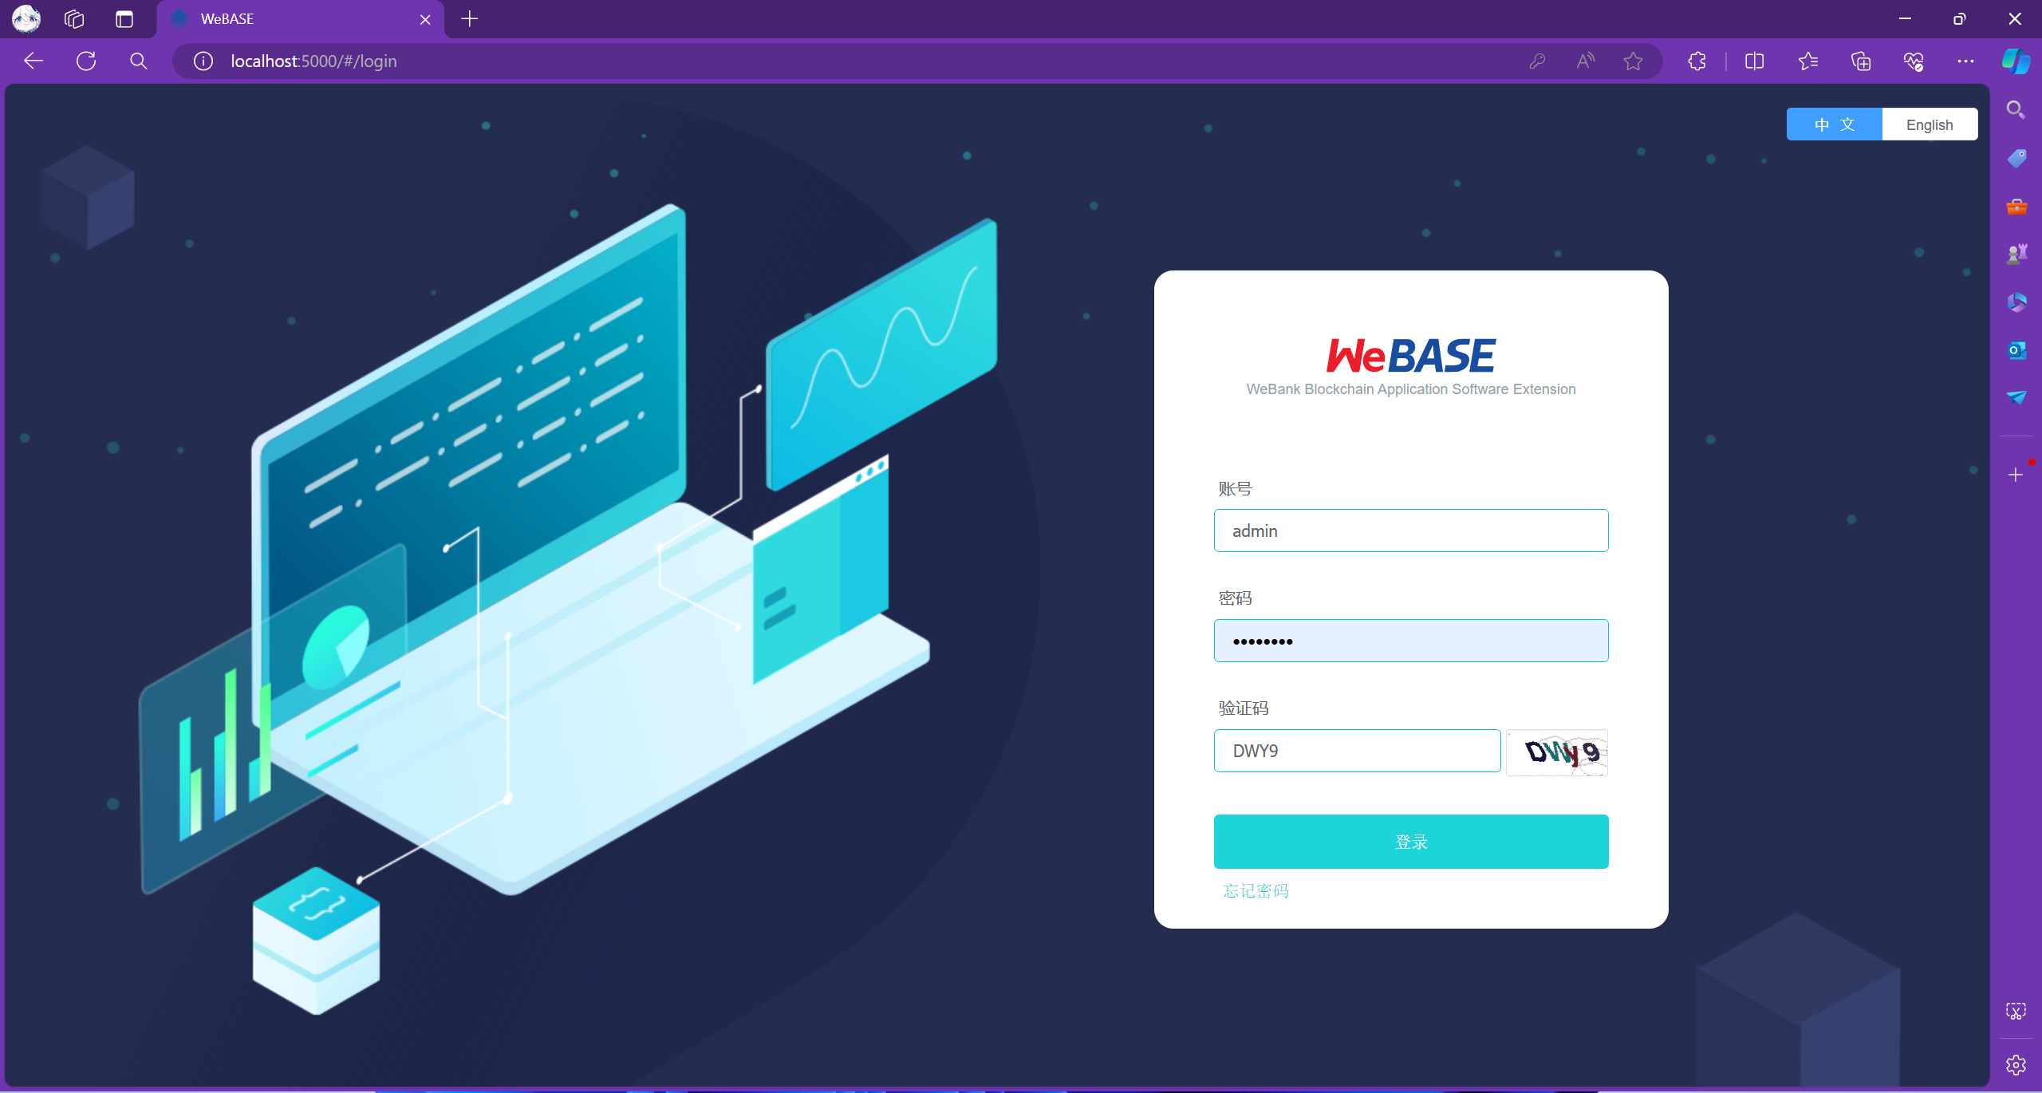

2)添加私链用户

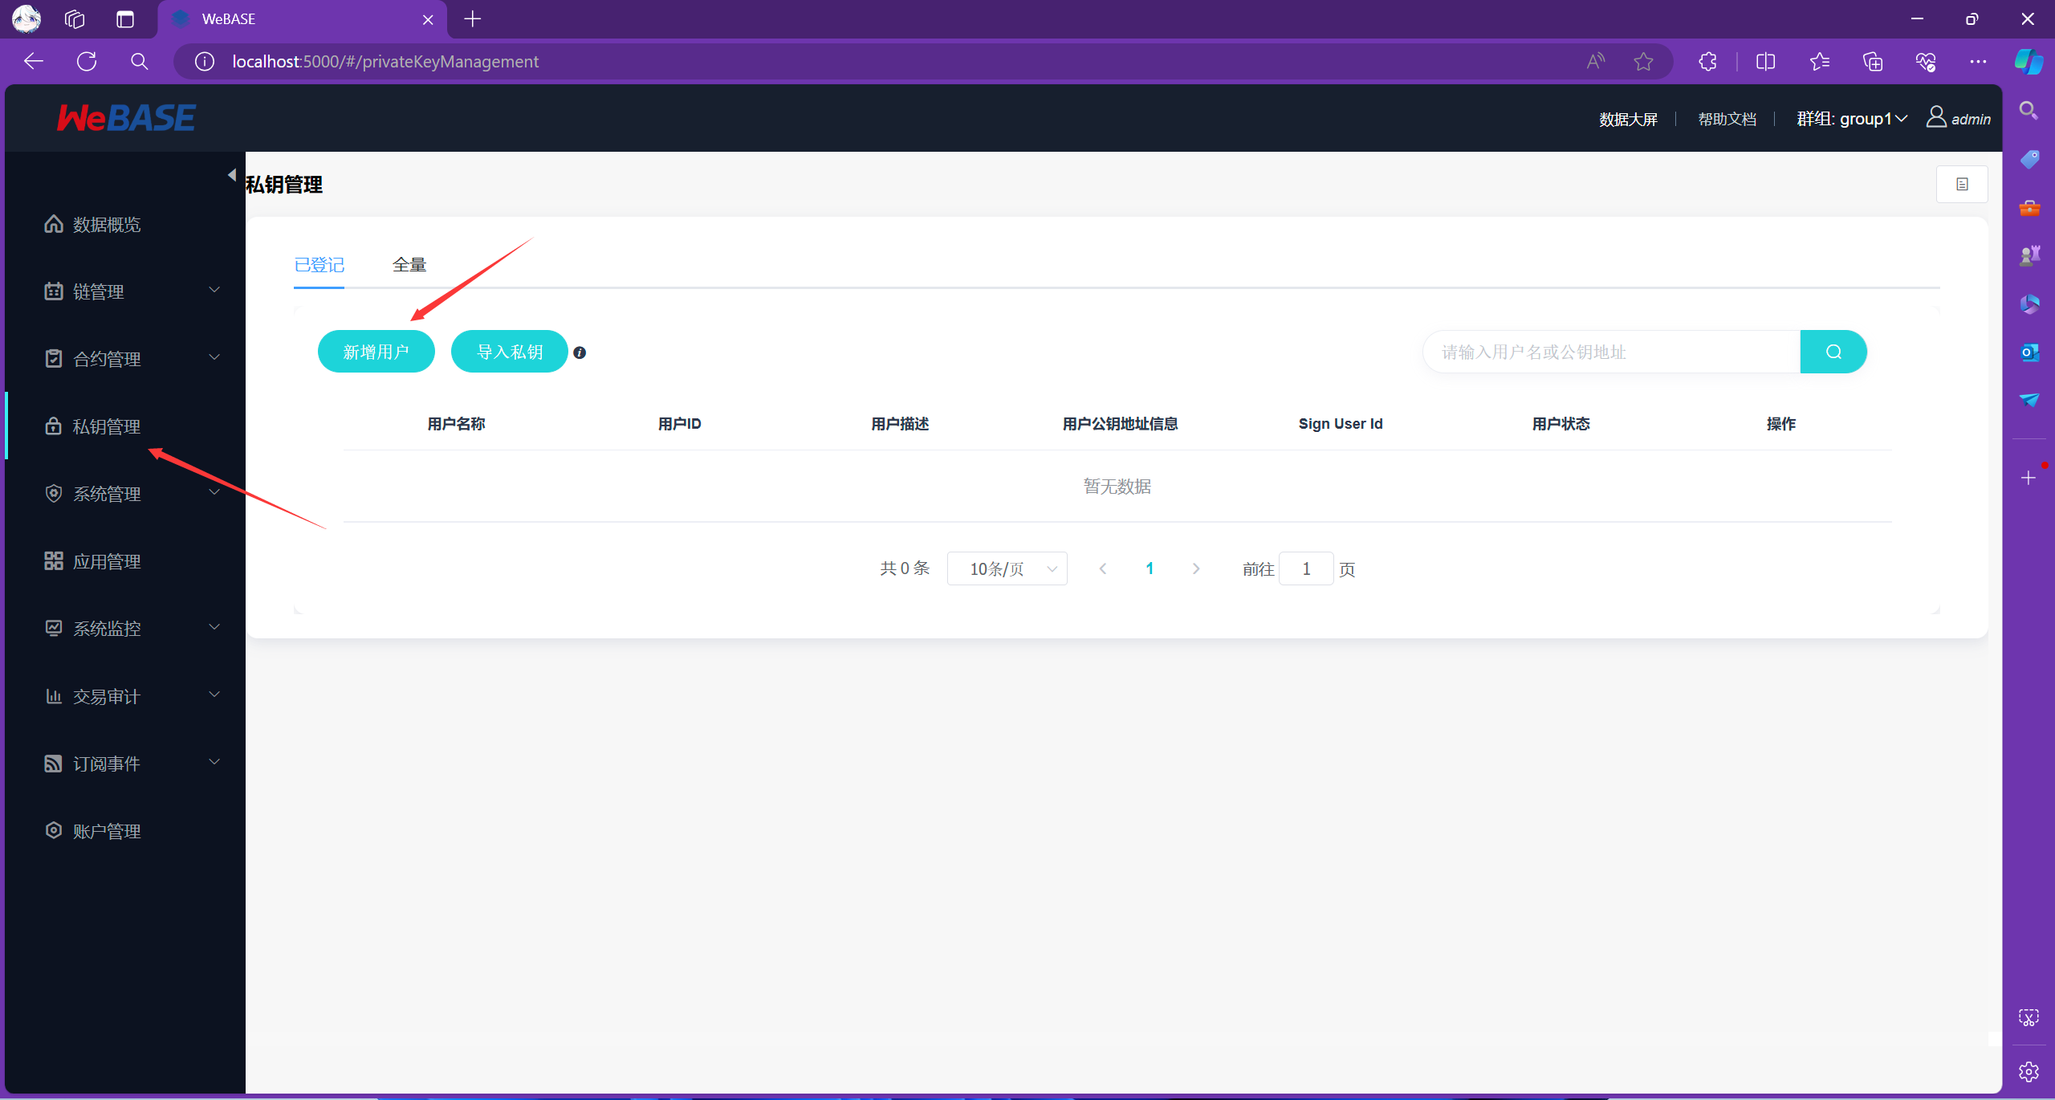

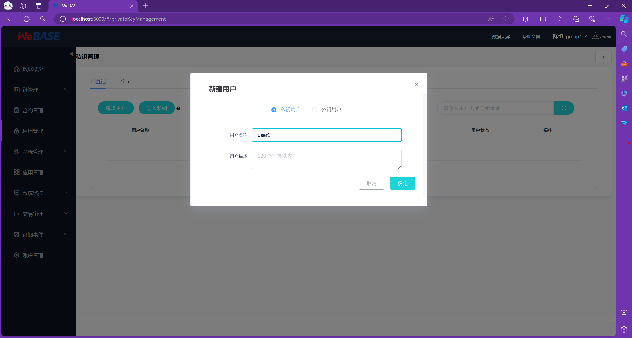

1. 选择智能合约并部署

智能合约部署方式有多种，这里我们使用WeBase提供的可视化图形界面进行部署，此种方式较为方便简单，不易出错

* 1. 上传智能合约：这里我们使用Fisco提供的合约仓库中的Table.sol和TableTest.sol

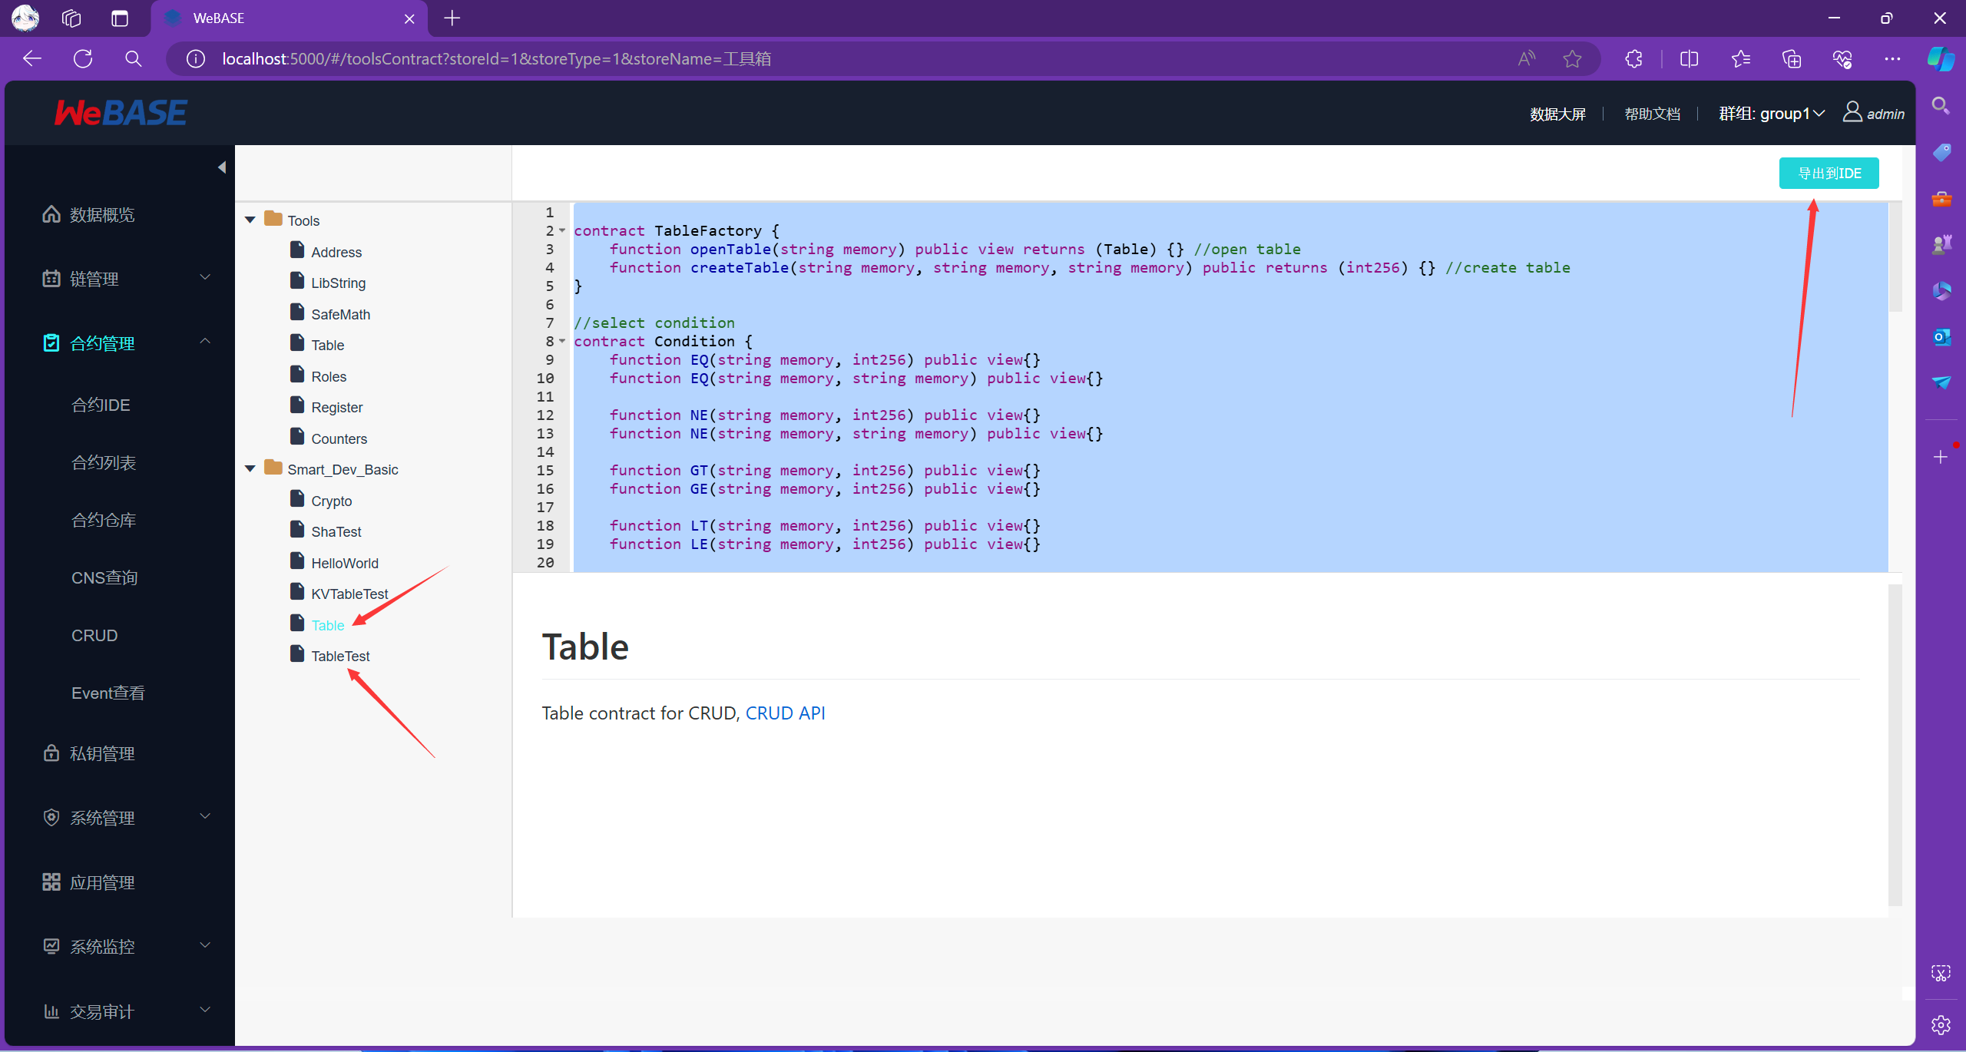

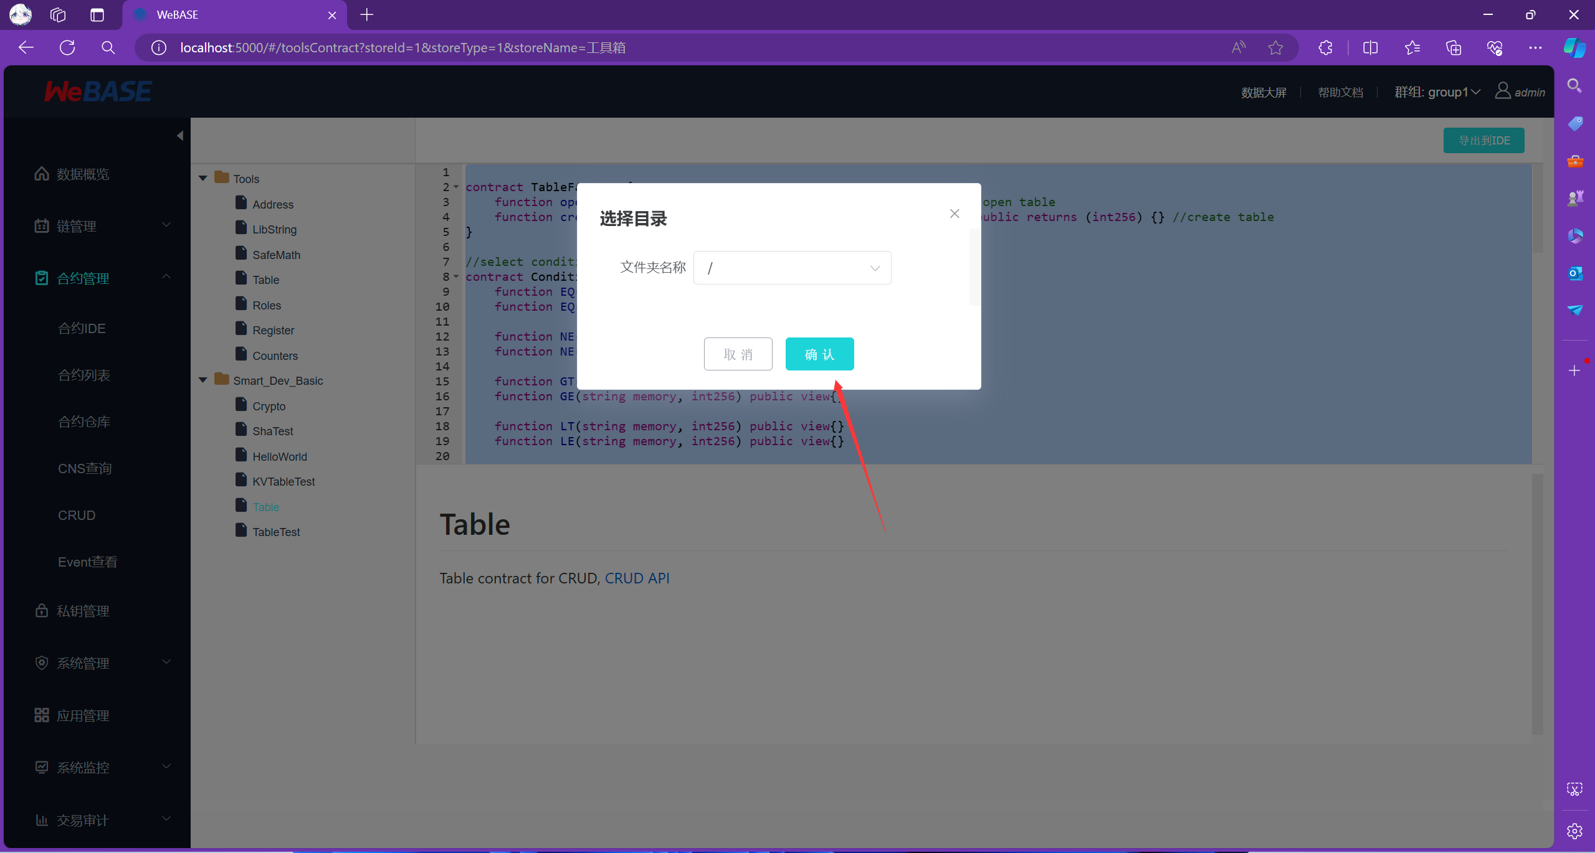

现在，我们去到合约IDE中，就可以看到我们选择的智能合约了

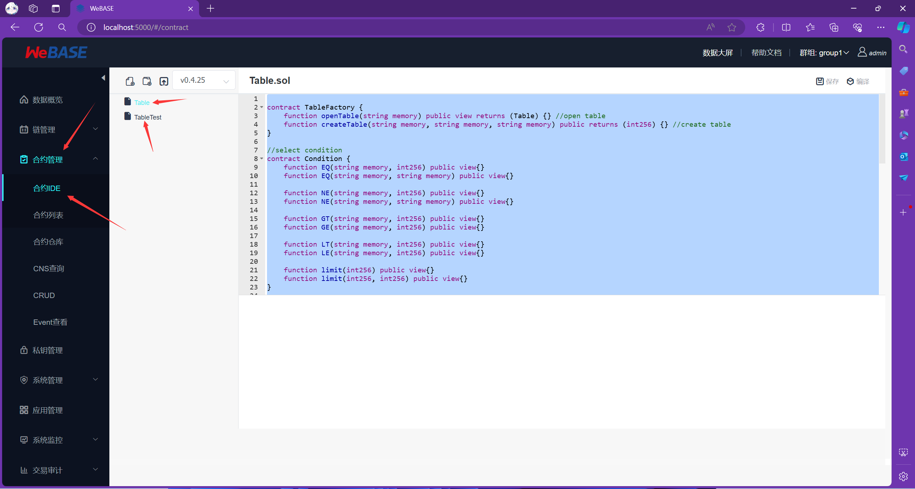

注意：如果需要上传自己编写的合约，请使用合约IDE的上传功能，示例如下：

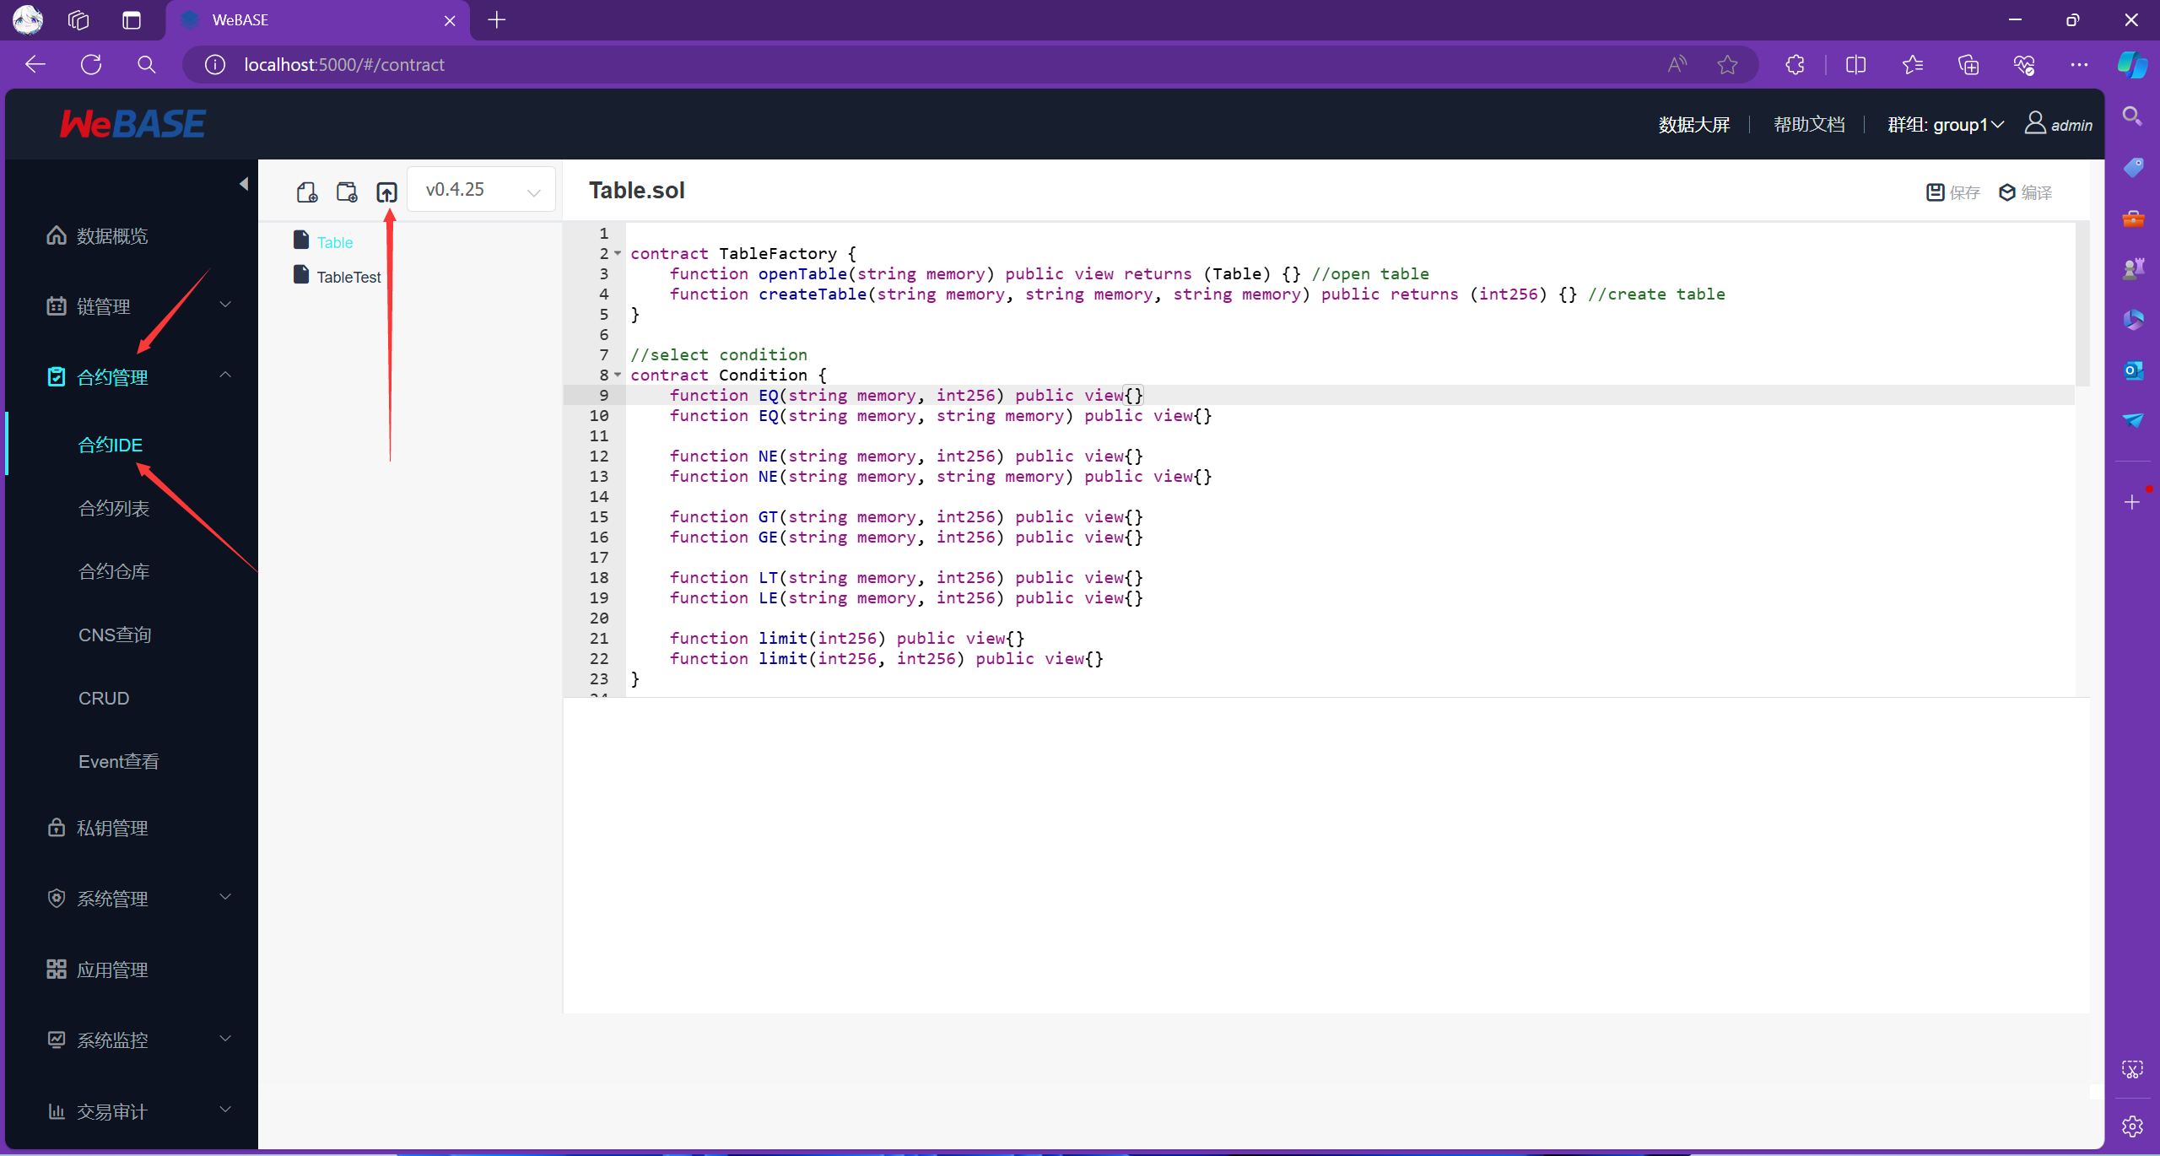

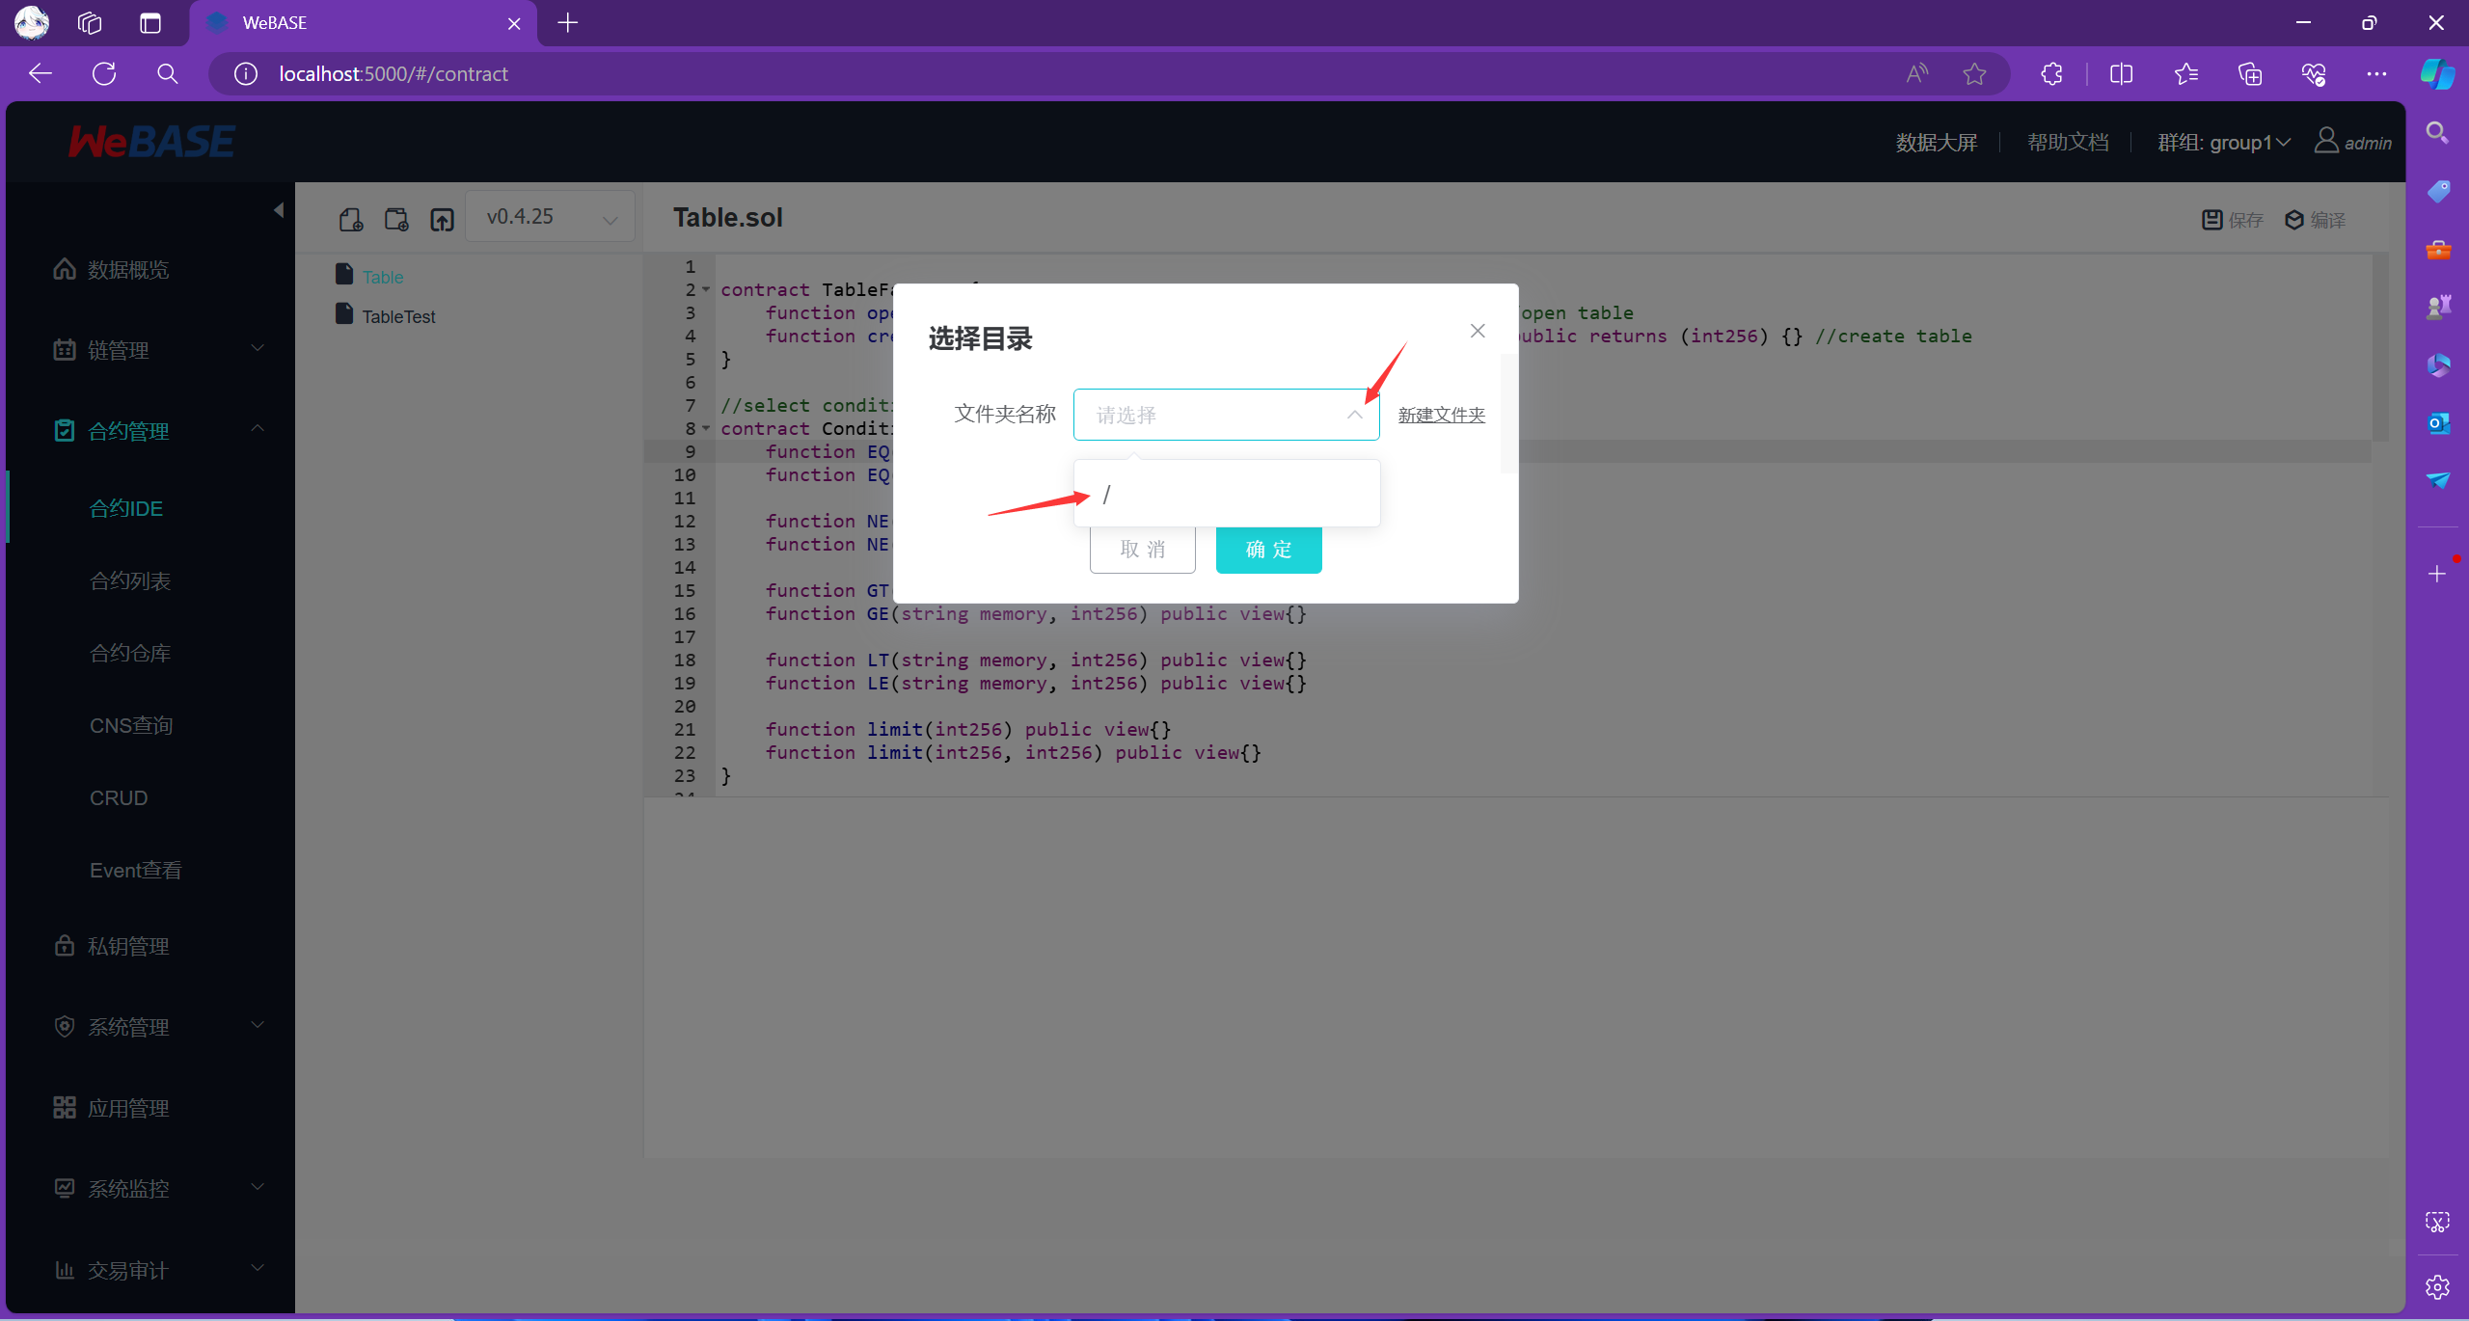

* 1. 部署智能合约

先选择编译，在点击部署

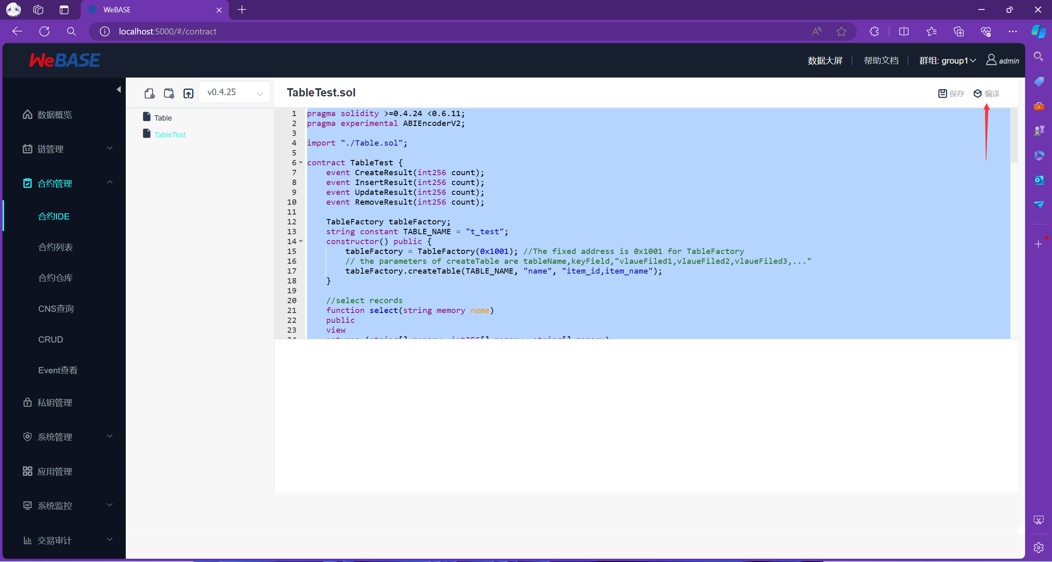

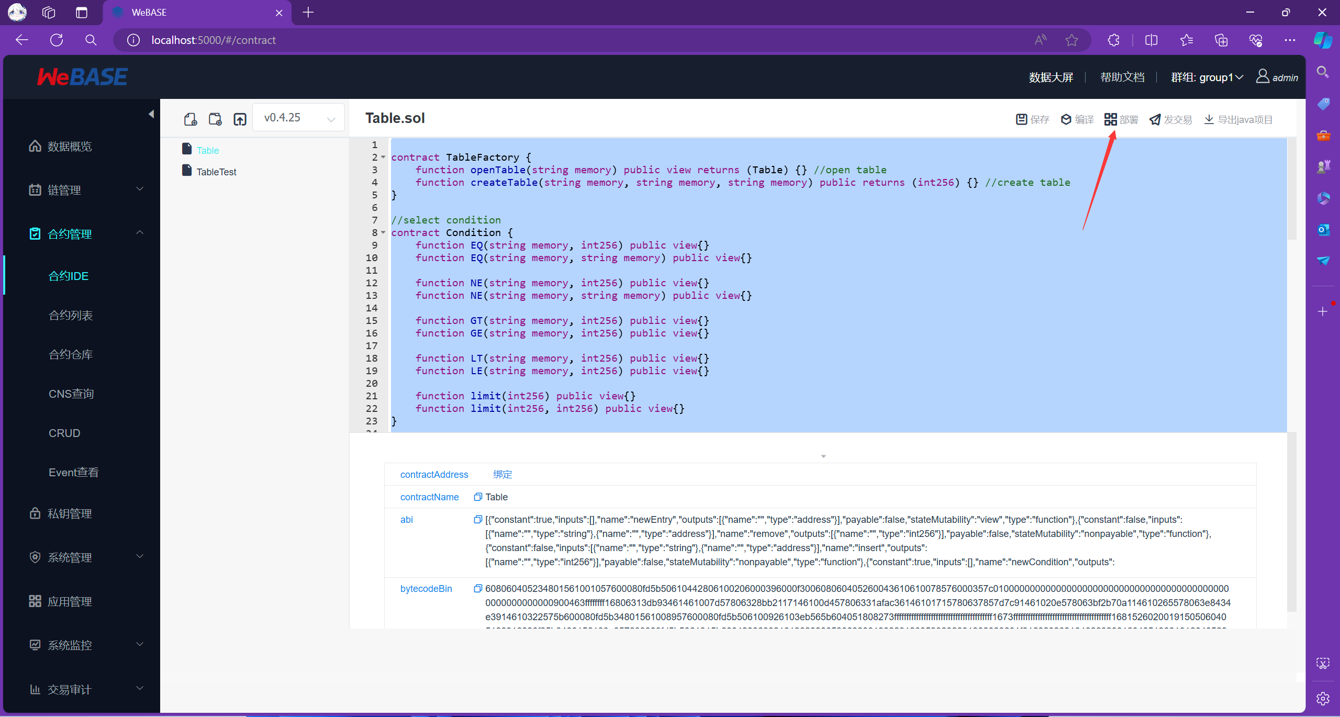

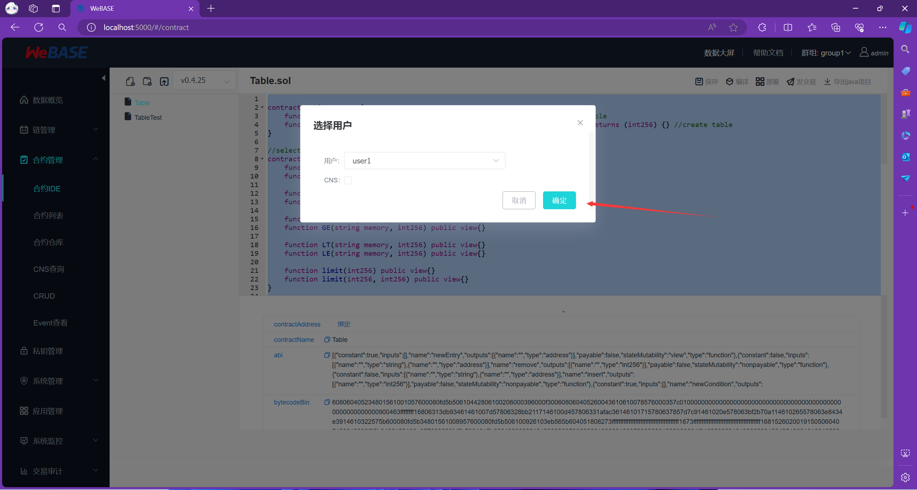

**二．编写后端Java程序**

这里，我们使用IDEA进行后端程序的编写 未安装IDEA的同学请先安装，并且请按照网上的教程配置一下Maven远程仓库

1. 创建后端项目：注意JDK需要选择大于等于17的版本，没有的话需要下载

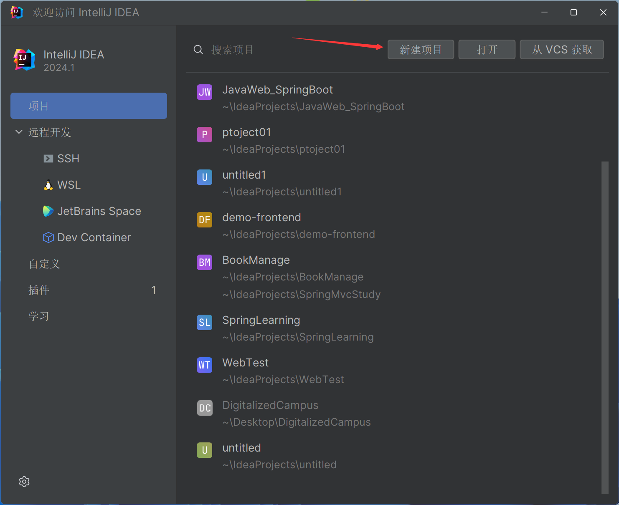

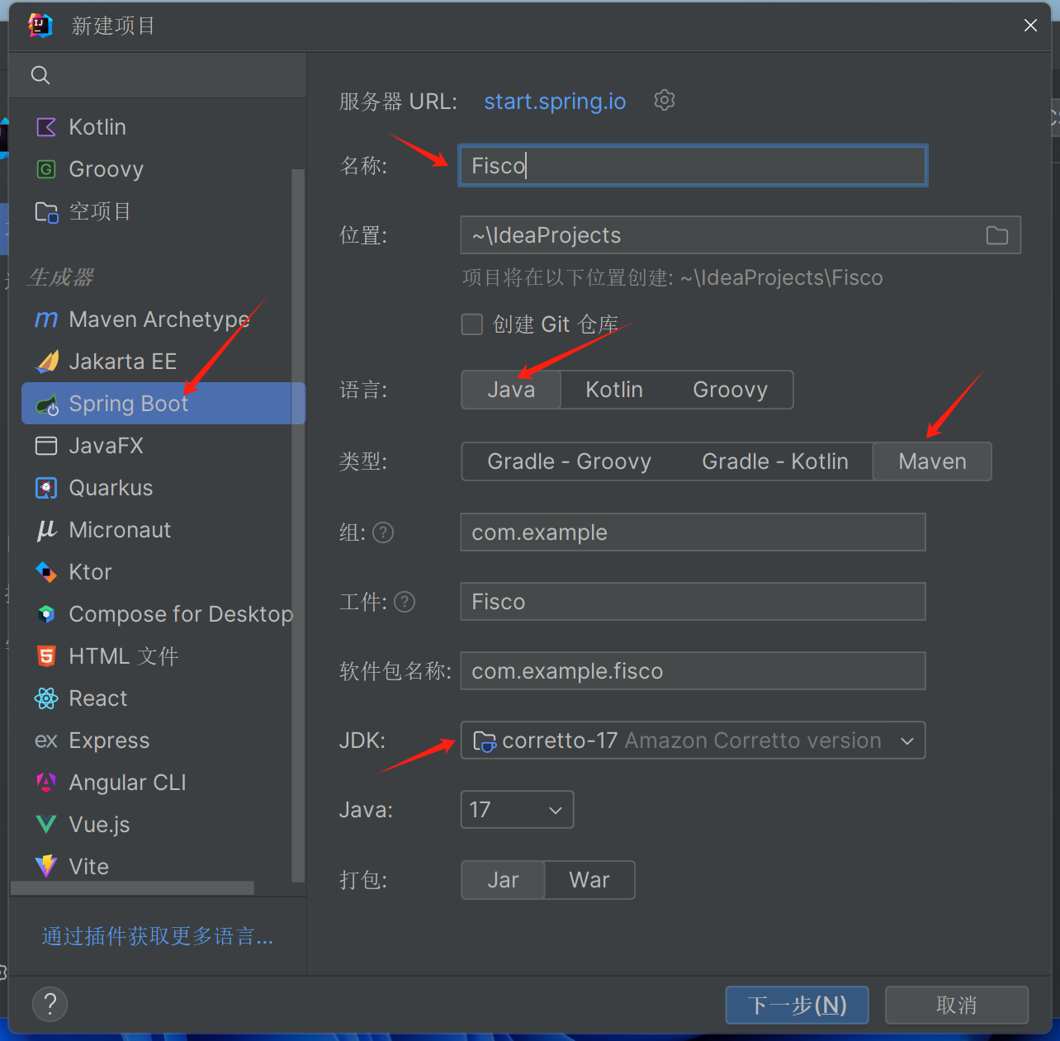

什么依赖项都不需要选择，直接点击创建

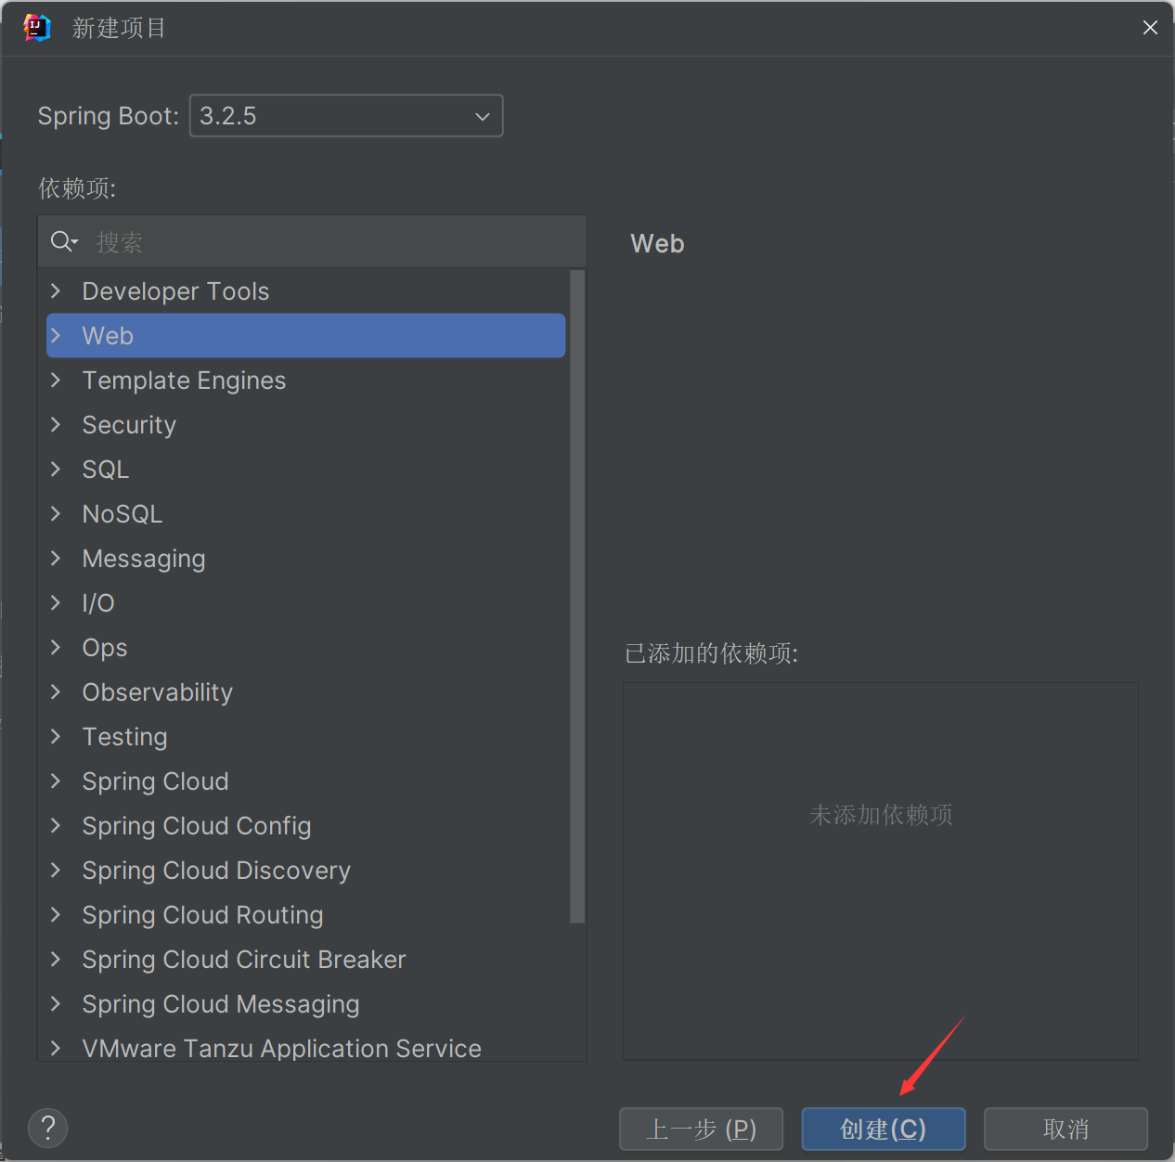

选择pom.xml，在dependencies标签中添加下面的依赖项：

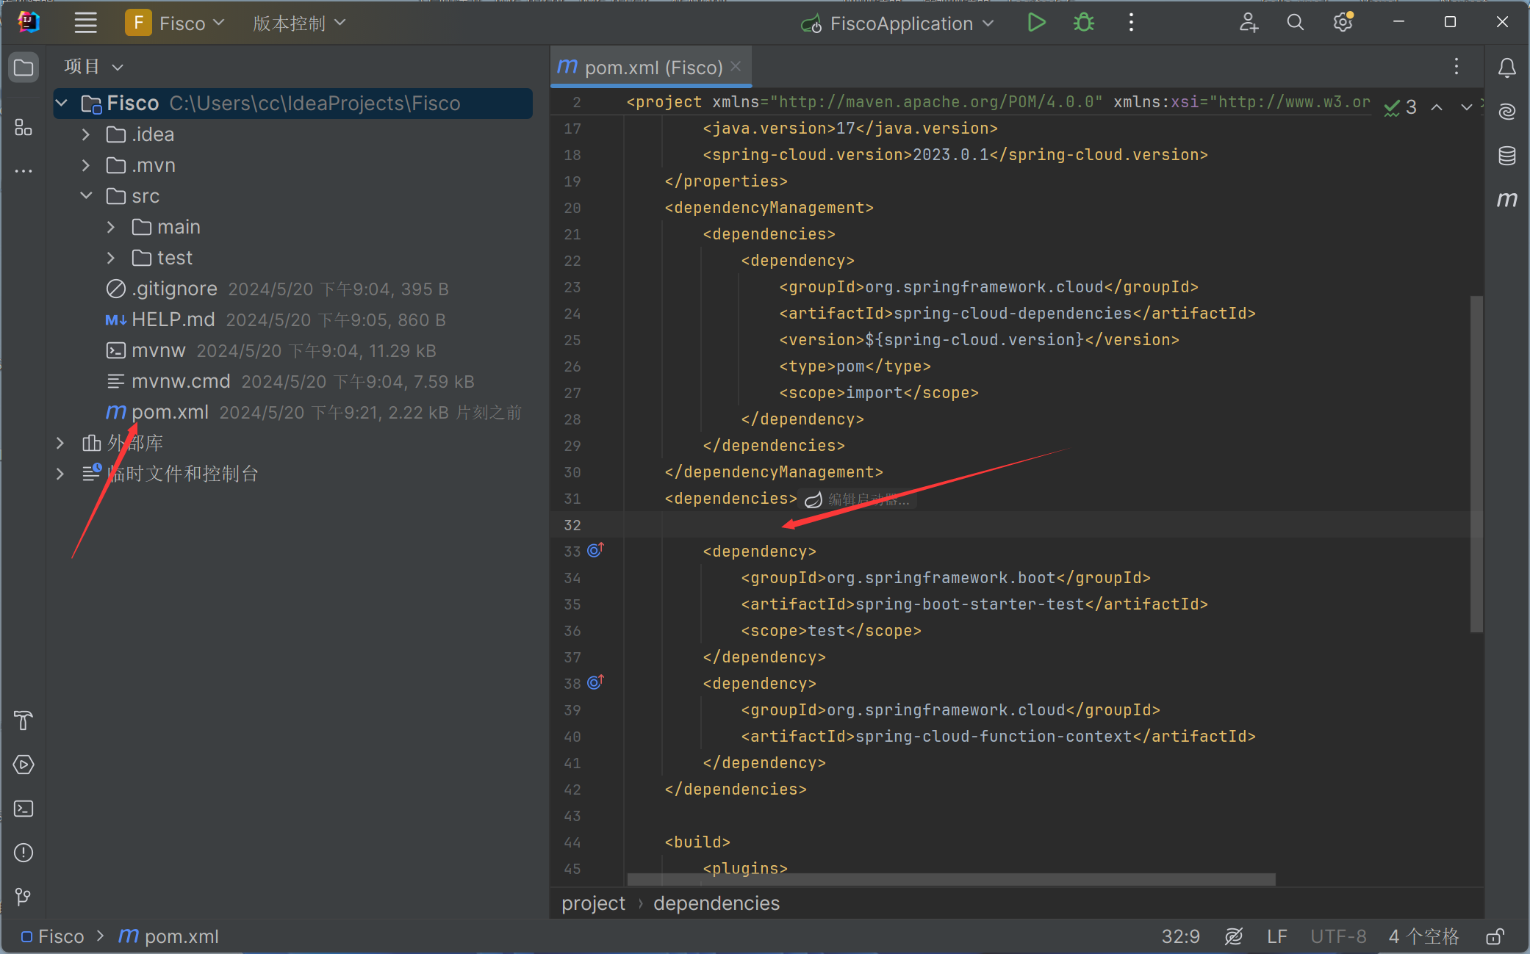

<dependency>  
 <groupId>org.springframework.boot</groupId>  
 <artifactId>spring-boot-starter-web</artifactId>  
</dependency>  
<dependency>  
 <groupId>org.projectlombok</groupId>  
 <artifactId>lombok</artifactId>  
 <optional>true</optional>  
</dependency>

<dependency>  
            <groupId>org.fisco-bcos.java-sdk</groupId>  
            <artifactId>fisco-bcos-java-sdk</artifactId>  
            <version>2.9.1</version>

</dependency>

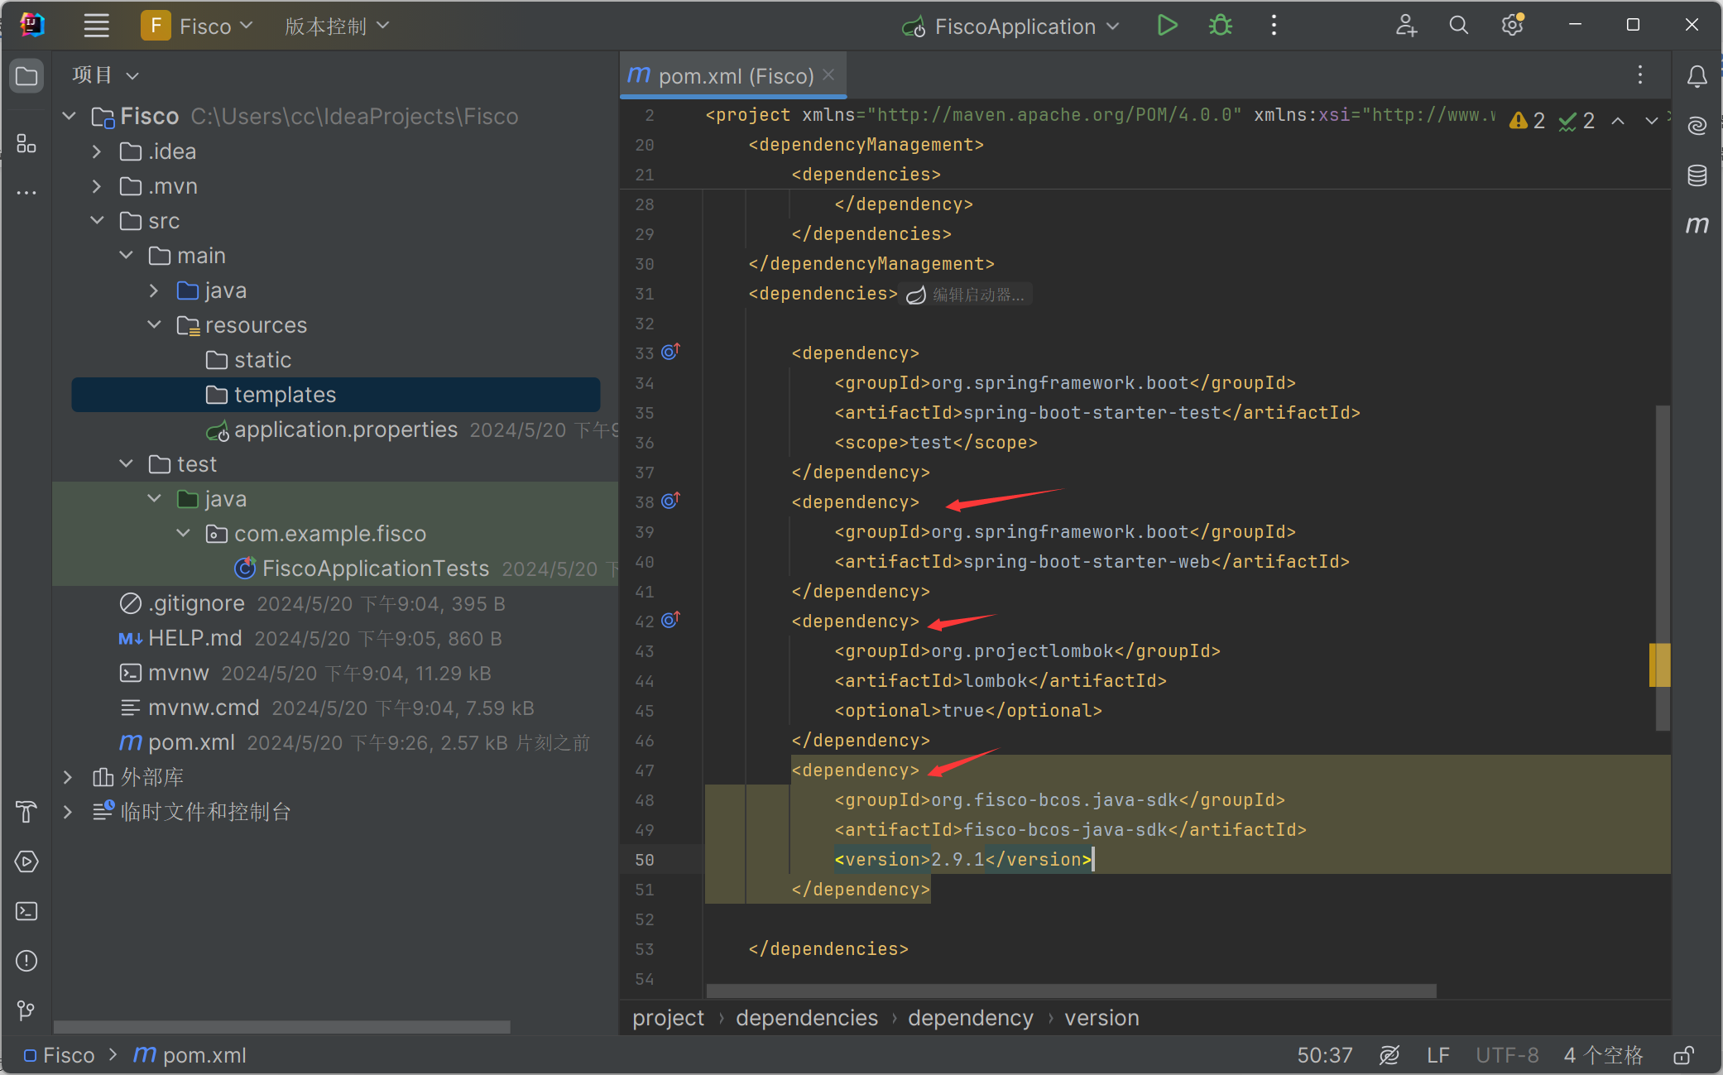

在添加完成依赖项后，请点击右侧边栏的Maven标签，并点击刷新以加载依赖项

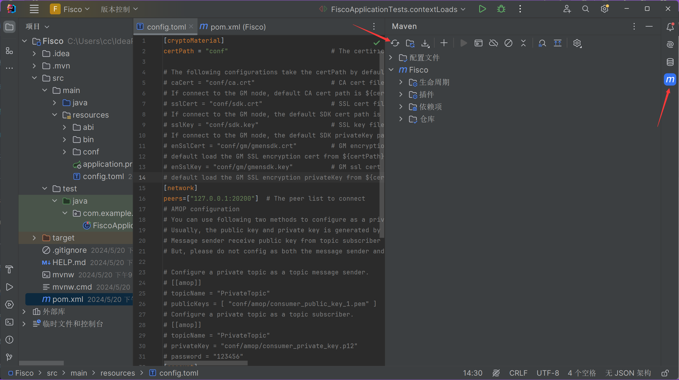

1. 编写后端程序
2. 新建三个文件夹（abi,bin,conf），位置如下图：

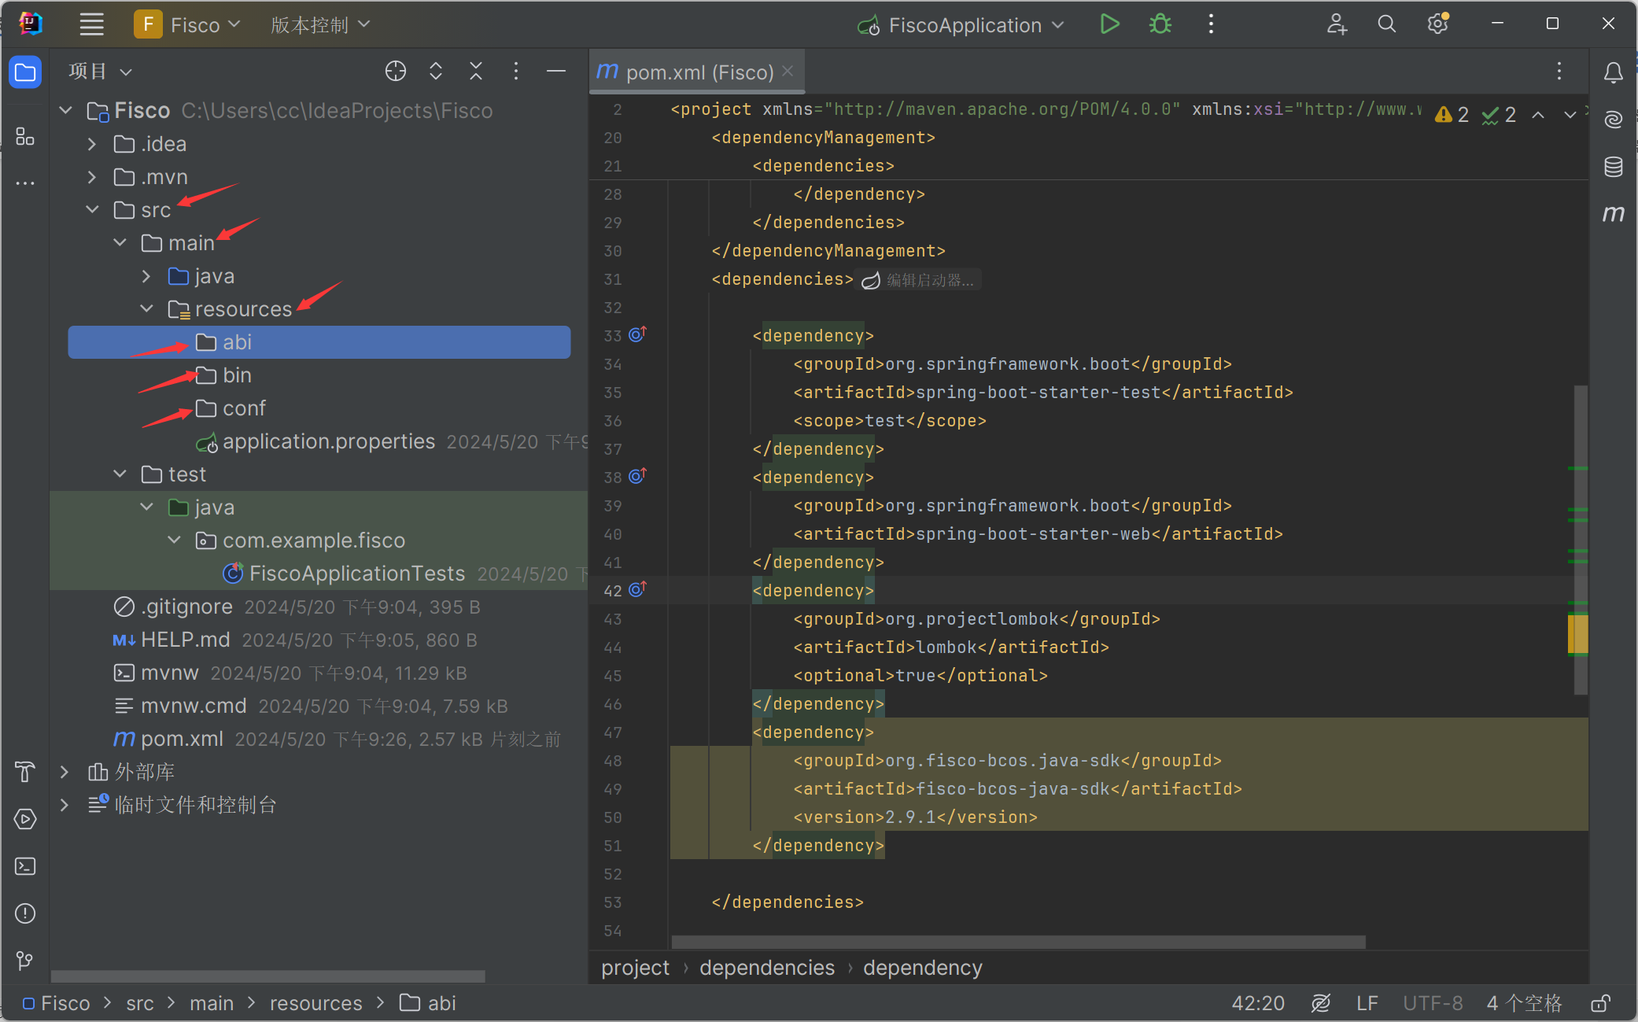

2）将合约的编译文件放分别放入对应的bin和abi文件夹，编译文件可在WeBase上下载： （在合约IDE中，选择侧边栏中的.sol文件，右键选择导出）

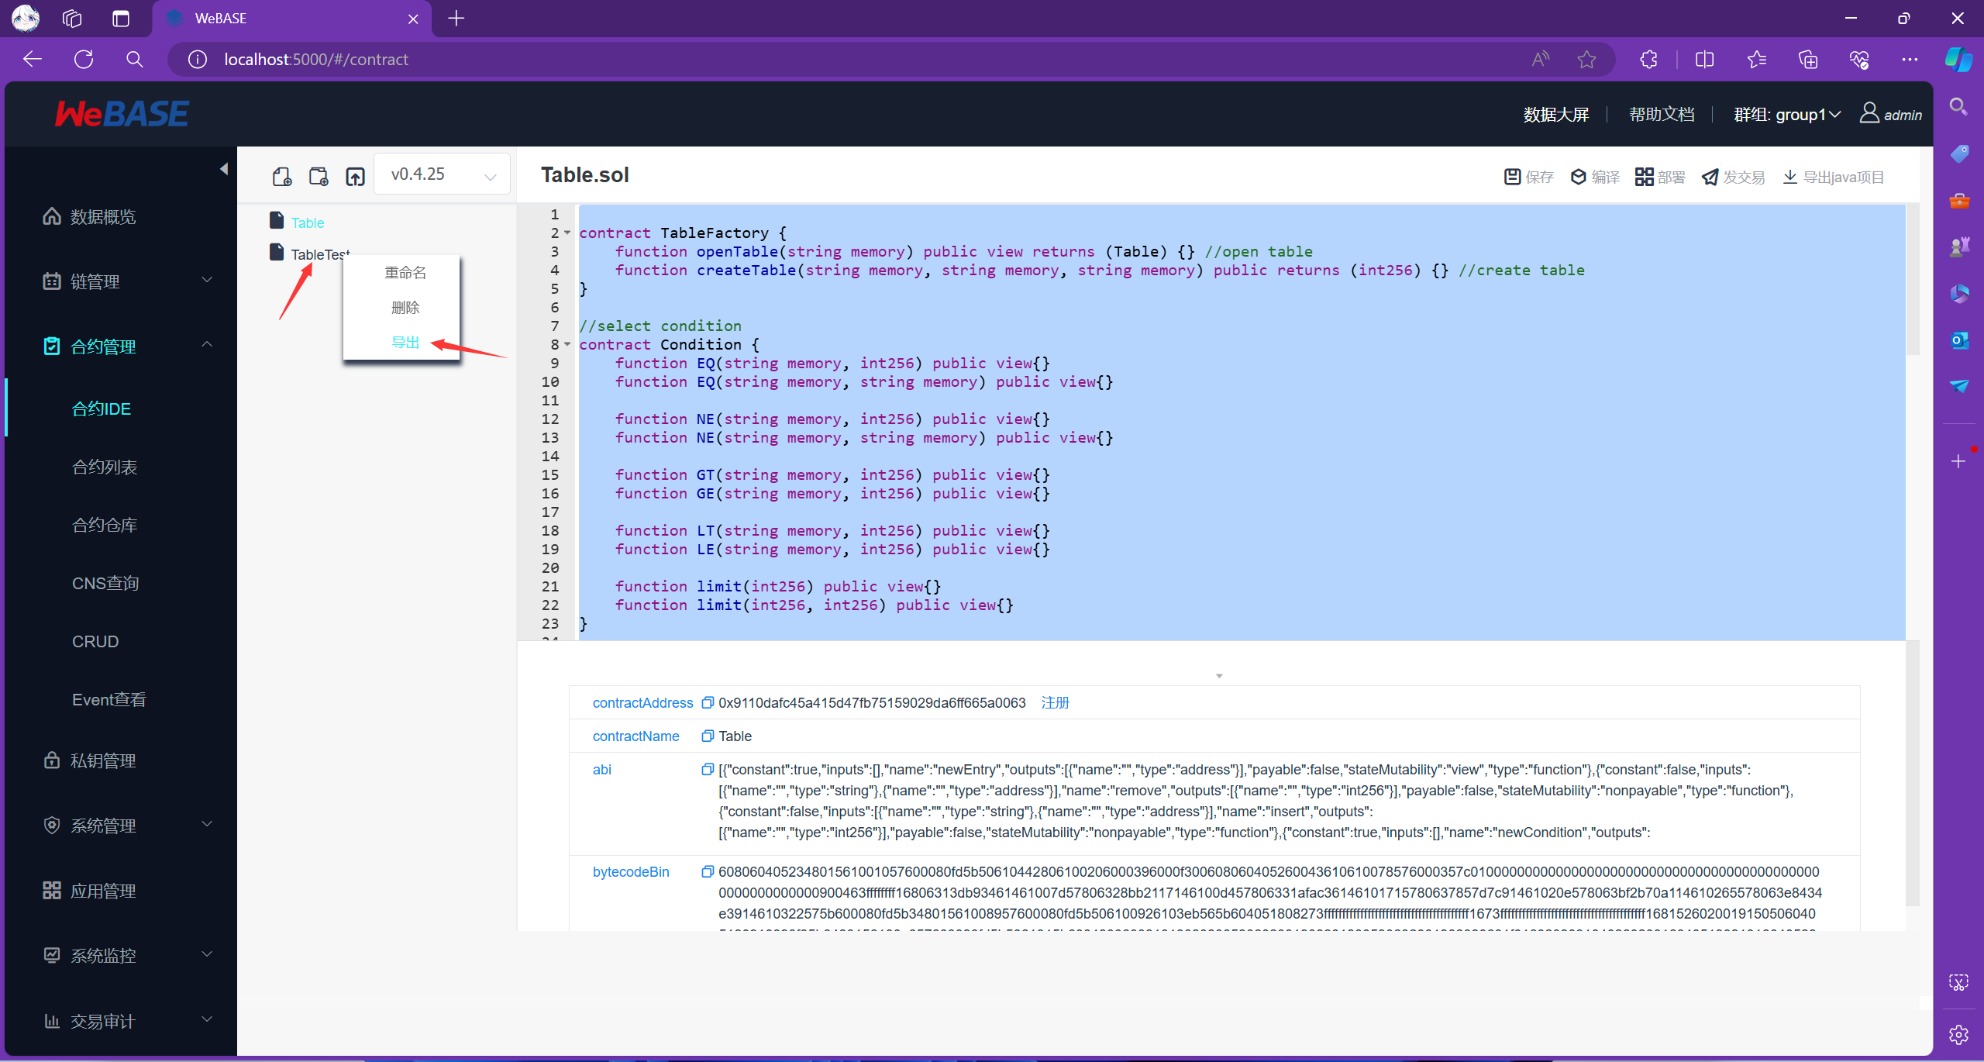

3）将下载的压缩包解压，将其中的abi和bin文件放到对应的文件夹：

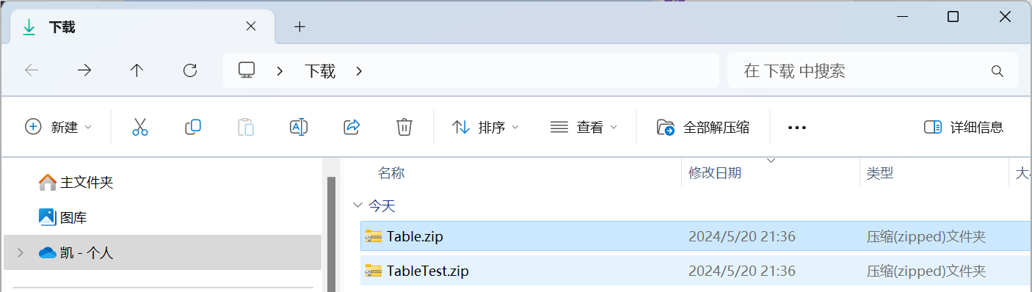  
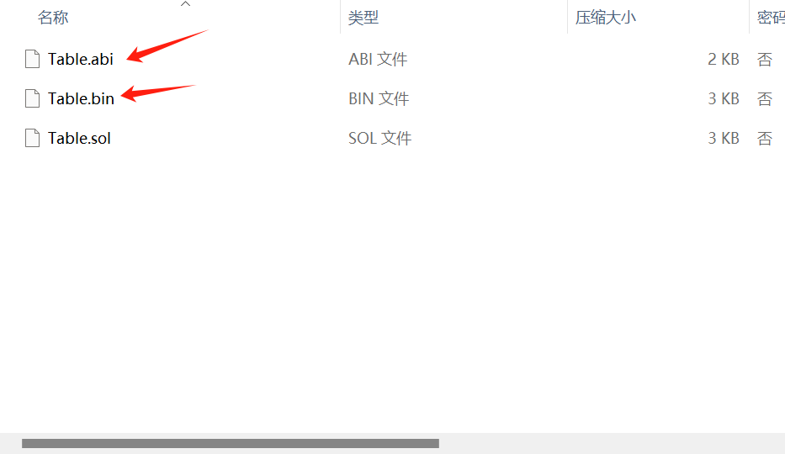

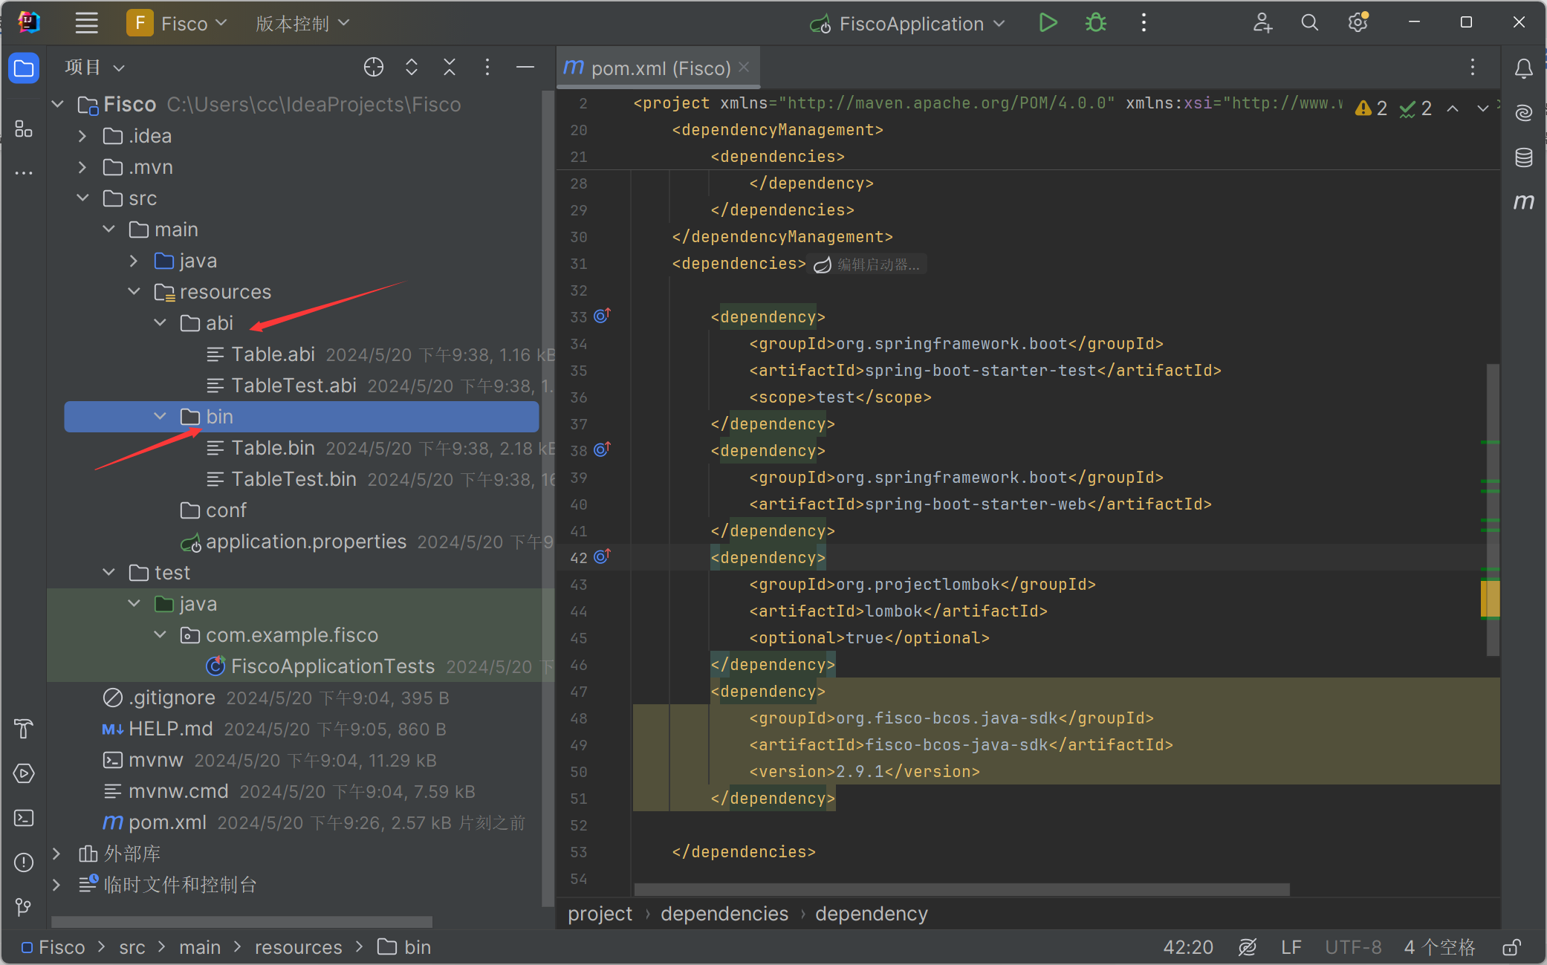

4）在文件管理器中，打开Ubuntu中的SDK文件夹（具体路径如图）并将其中的文件导入conf文件夹中：

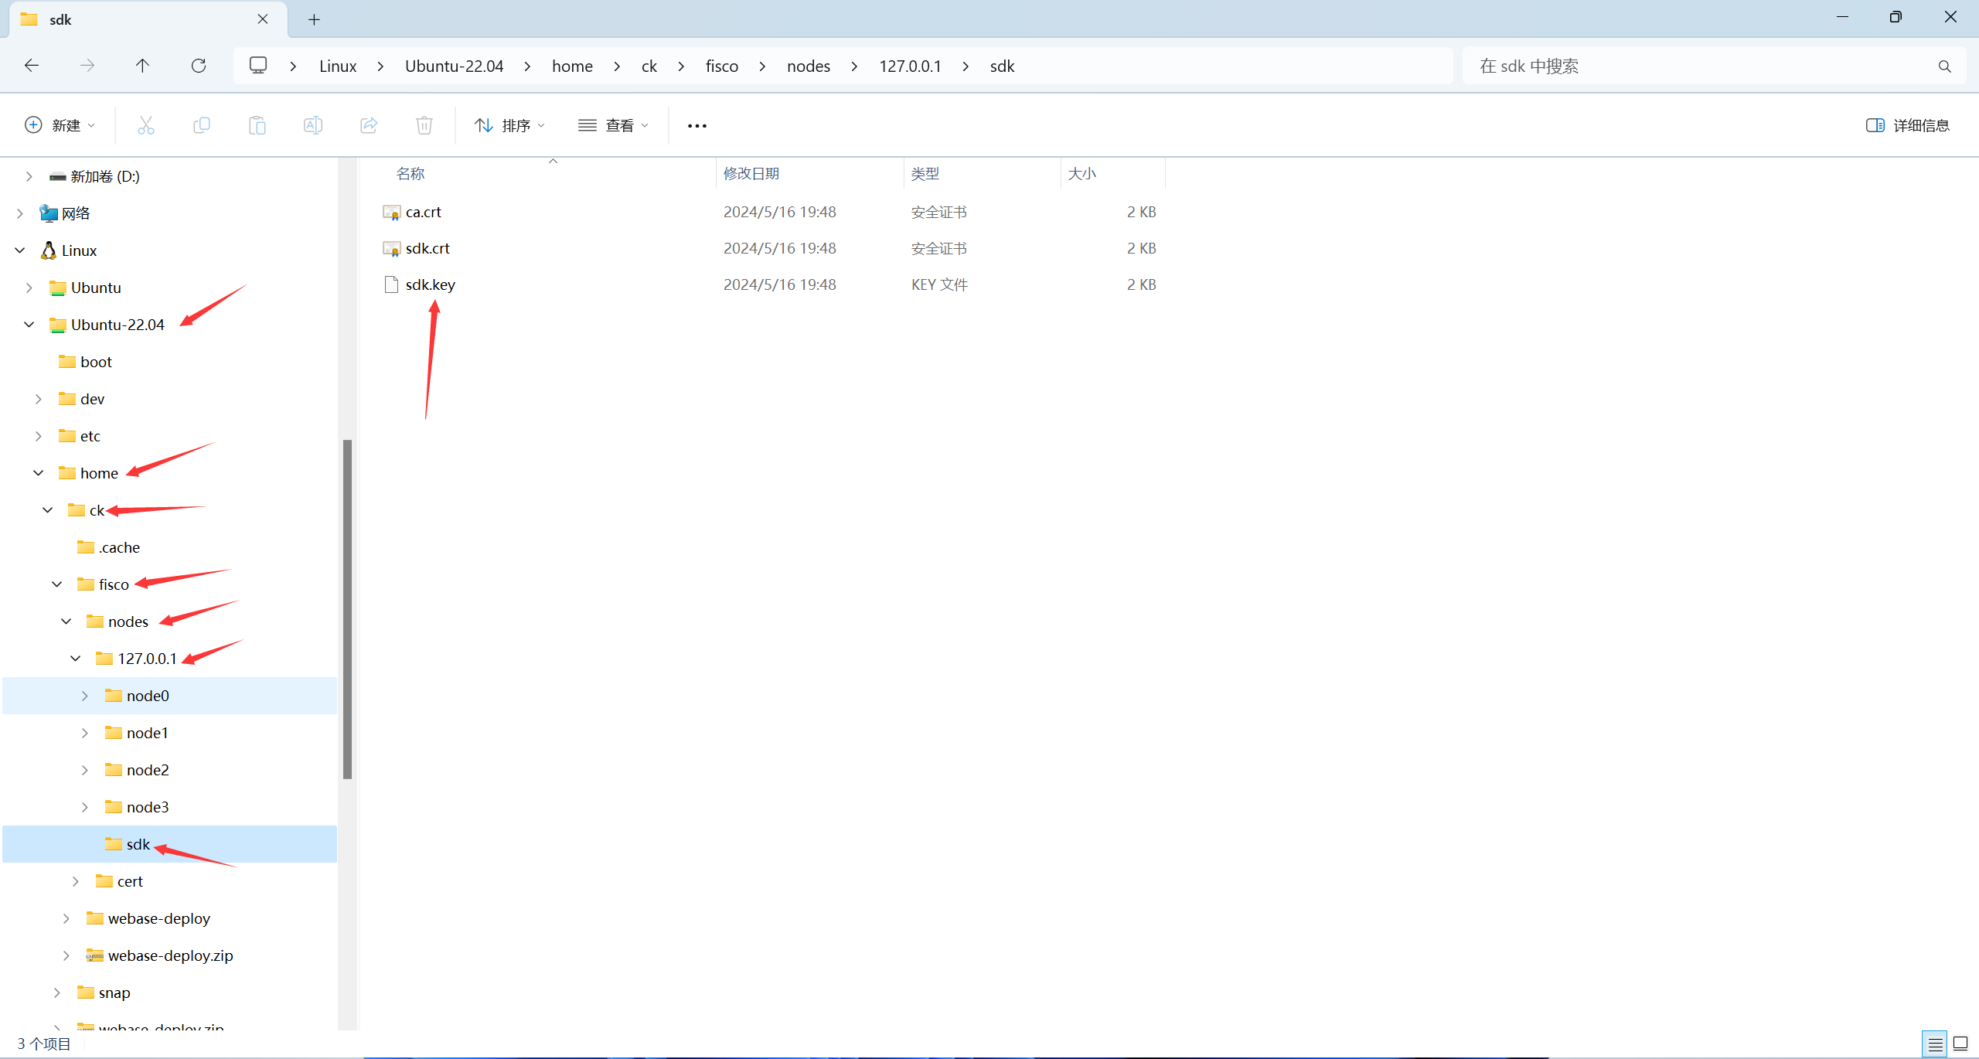

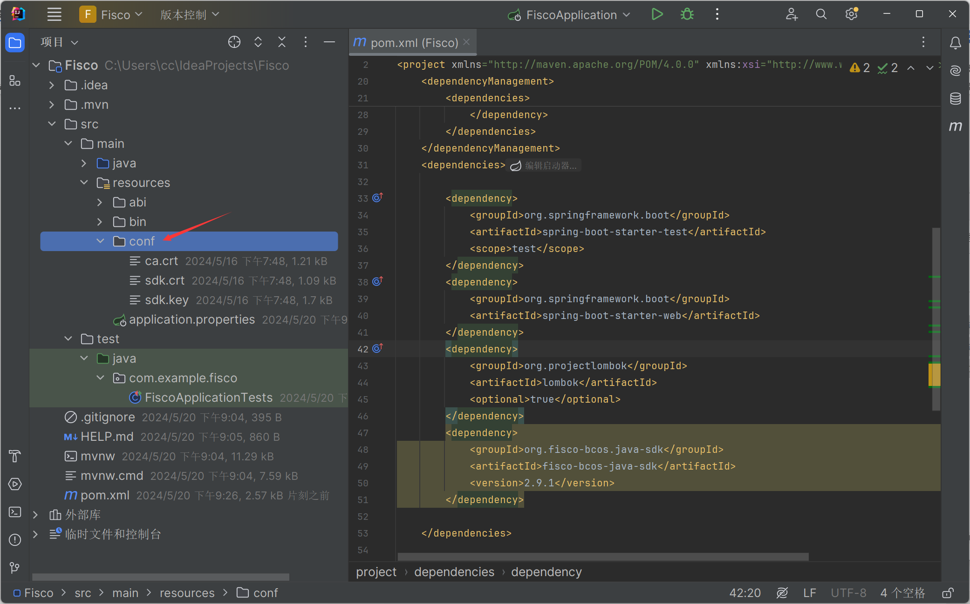

5）在resources文件夹中新建config.toml文件

文件内容如下：

[cryptoMaterial]

certPath = "conf" # The certification path

# The following configurations take the certPath by default if commented

# caCert = "conf/ca.crt" # CA cert file path

# If connect to the GM node, default CA cert path is ${certPath}/gm/gmca.crt

# sslCert = "conf/sdk.crt" # SSL cert file path

# If connect to the GM node, the default SDK cert path is ${certPath}/gm/gmsdk.crt

# sslKey = "conf/sdk.key" # SSL key file path

# If connect to the GM node, the default SDK privateKey path is ${certPath}/gm/gmsdk.key

# enSslCert = "conf/gm/gmensdk.crt" # GM encryption cert file path

# default load the GM SSL encryption cert from ${certPath}/gm/gmensdk.crt

# enSslKey = "conf/gm/gmensdk.key" # GM ssl cert file path

# default load the GM SSL encryption privateKey from ${certPath}/gm/gmensdk.key

[network]

peers=["127.0.0.1:20200"] # The peer list to connect

# AMOP configuration

# You can use following two methods to configure as a private topic message sender or subscriber.

# Usually, the public key and private key is generated by subscriber.

# Message sender receive public key from topic subscriber then make configuration.

# But, please do not config as both the message sender and the subscriber of one private topic, or you may send the message to yourself.

# Configure a private topic as a topic message sender.

# [[amop]]

# topicName = "PrivateTopic"

# publicKeys = [ "conf/amop/consumer_public_key_1.pem" ] # Public keys of the nodes that you want to send AMOP message of this topic to.

# Configure a private topic as a topic subscriber.

# [[amop]]

# topicName = "PrivateTopic"

# privateKey = "conf/amop/consumer_private_key.p12" # Your private key that used to subscriber verification.

# password = "123456"

[account]

keyStoreDir = "account" # The directory to load/store the account file, default is "account"

# accountFilePath = "" # The account file path (default load from the path specified by the keyStoreDir)

accountFileFormat = "pem" # The storage format of account file (Default is "pem", "p12" as an option)

# accountAddress = "" # The transactions sending account address

# Default is a randomly generated account

# The randomly generated account is stored in the path specified by the keyStoreDir

# password = "" # The password used to load the account file

[threadPool]

channelProcessorThreadSize = "4" # The size of the thread pool to process channel callback

# Default is the number of cpu cores

receiptProcessorThreadSize = "4" # The size of the thread pool to process transaction receipt notification

# Default is the number of cpu cores

maxBlockingQueueSize = "102400"

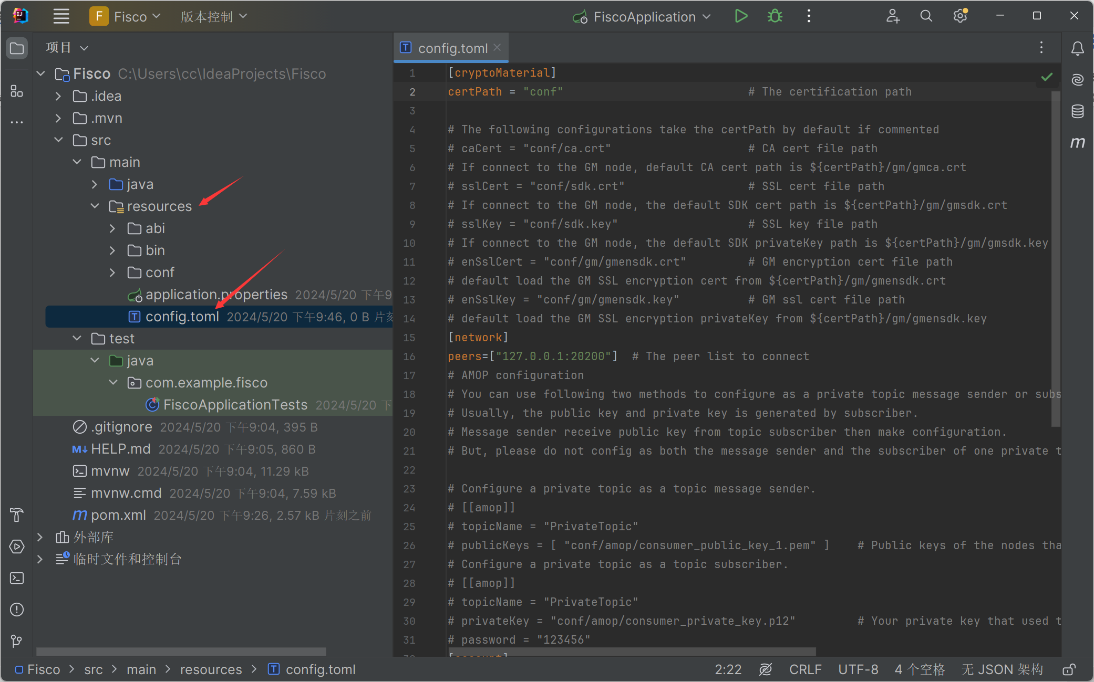

6）打开FiscoApplicationTests.Java文件，添加以下内容：

package com.example.fisco;  
  
import org.fisco.bcos.sdk.BcosSDK;  
import org.fisco.bcos.sdk.abi.ABICodecException;  
import org.fisco.bcos.sdk.client.Client;  
import org.fisco.bcos.sdk.crypto.keypair.CryptoKeyPair;  
import org.fisco.bcos.sdk.transaction.manager.AssembleTransactionProcessor;  
import org.fisco.bcos.sdk.transaction.manager.TransactionProcessorFactory;  
import org.fisco.bcos.sdk.transaction.model.dto.TransactionResponse;  
import org.fisco.bcos.sdk.transaction.model.exception.TransactionBaseException;  
import org.junit.jupiter.api.BeforeAll;  
import org.junit.jupiter.api.Test;  
import org.springframework.boot.test.context.SpringBootTest;  
  
import java.util.ArrayList;  
import java.util.List;  
  
@SpringBootTest  
class FiscoApplicationTests {  
 static final String *configFile* ="src/main/resources/config.toml";  
 static final String *address*="";//合约地址 需要到WeBase中查看合约编译后的具体地址  
 static BcosSDK *sdk*;  
 static Client *client*;  
 static AssembleTransactionProcessor *transactionProcessor*;  
 @BeforeAll  
 static void setUpBeforeClass() throws Exception {  
 *sdk*=BcosSDK.*build*(*configFile*);  
 *client*=*sdk*.getClient(1);  
 CryptoKeyPair keyPair = client.getCryptoSuite().createKeyPair();  
 *transactionProcessor* = TransactionProcessorFactory.*createAssembleTransactionProcessor*(client,keyPair,"src/main/resources/abi/", "src/main/resources/bin/");  
 }  
  
 @Test  
 void contextLoads() throws ABICodecException, TransactionBaseException {  
 List<Object> params=new ArrayList<>();  
 String MethodName=""; //需要调用的合约中某一个方法的名称  
 params.add("");//方法需要携带的参数  
 params.add("");  
 params.add("");  
 TransactionResponse response = *transactionProcessor*.sendTransactionAndGetResponseByContractLoader("TableTest", *address*, MethodName, params);  
 System.*out*.println(response);  
 }  
  
}

其中address需要到WeBase中查看，然后填写到address中：

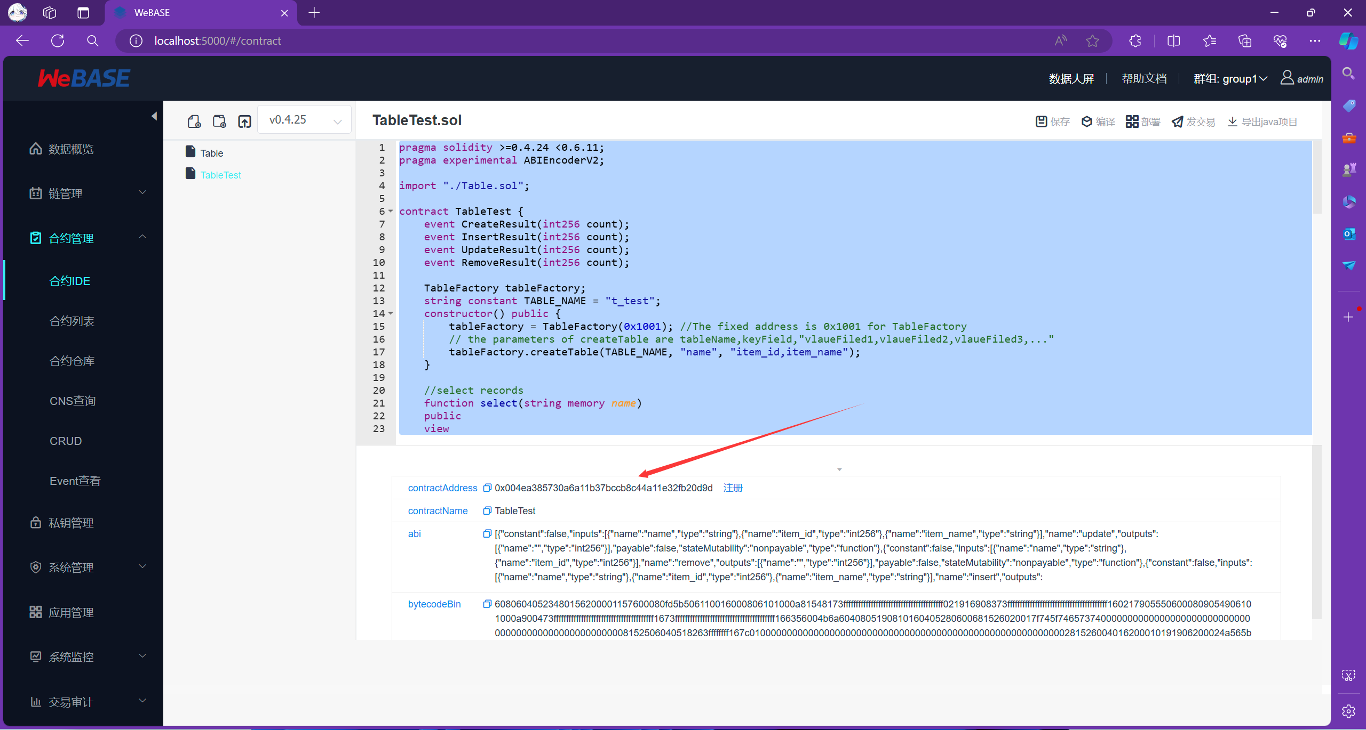

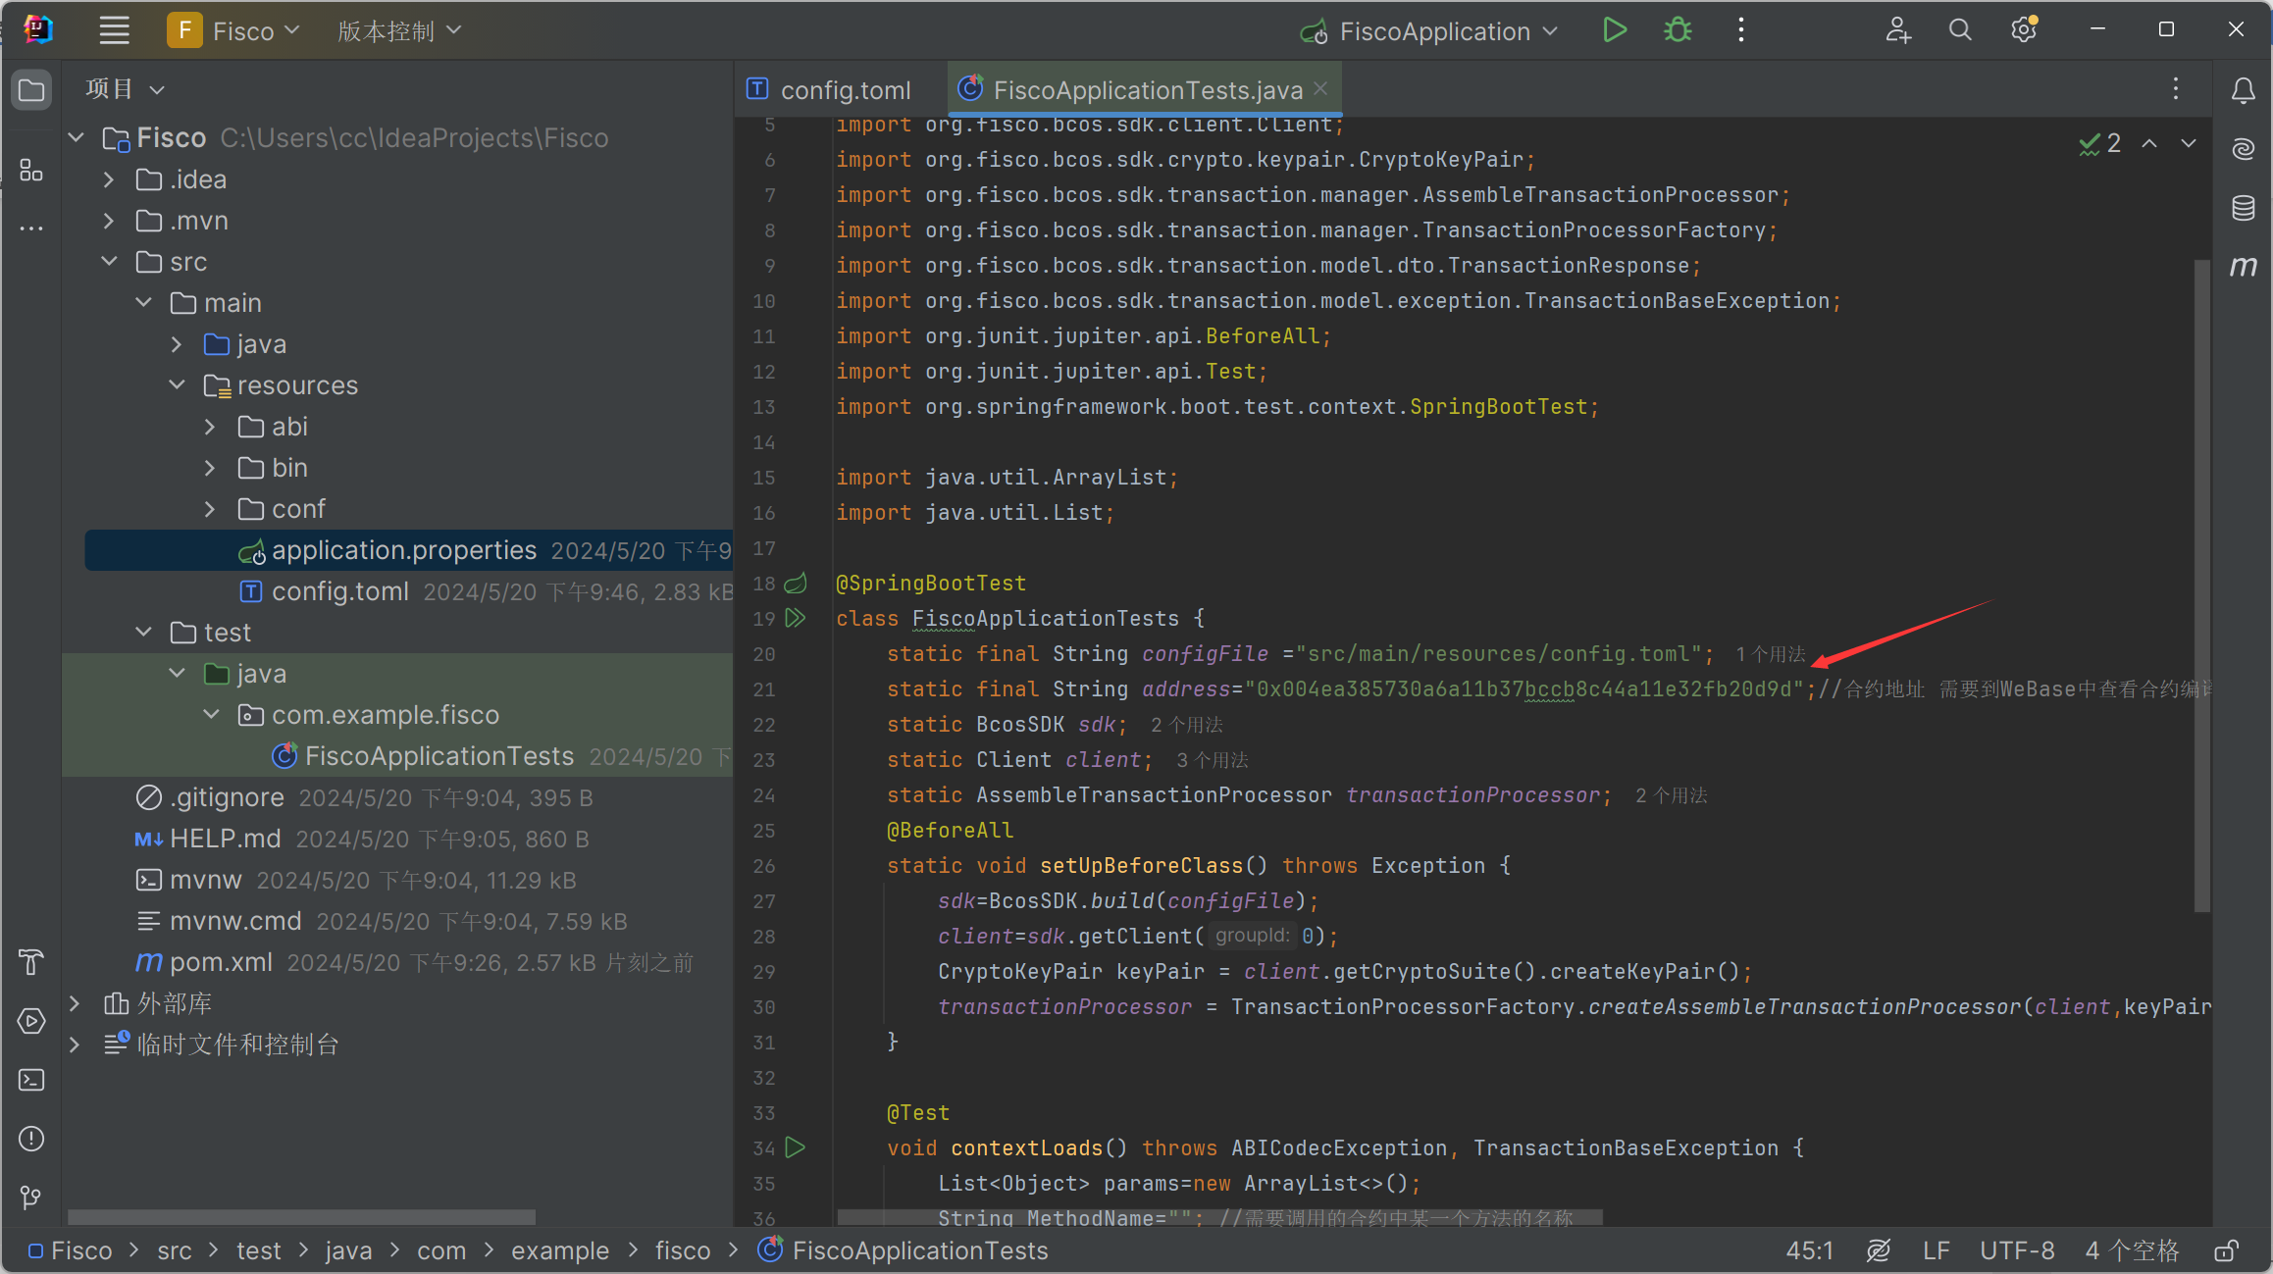

还有MethodName和Params参数需要填写，具体内容取决于你的合约中的函数名称以及函数参数（点击发交易可以看到具体的内容）

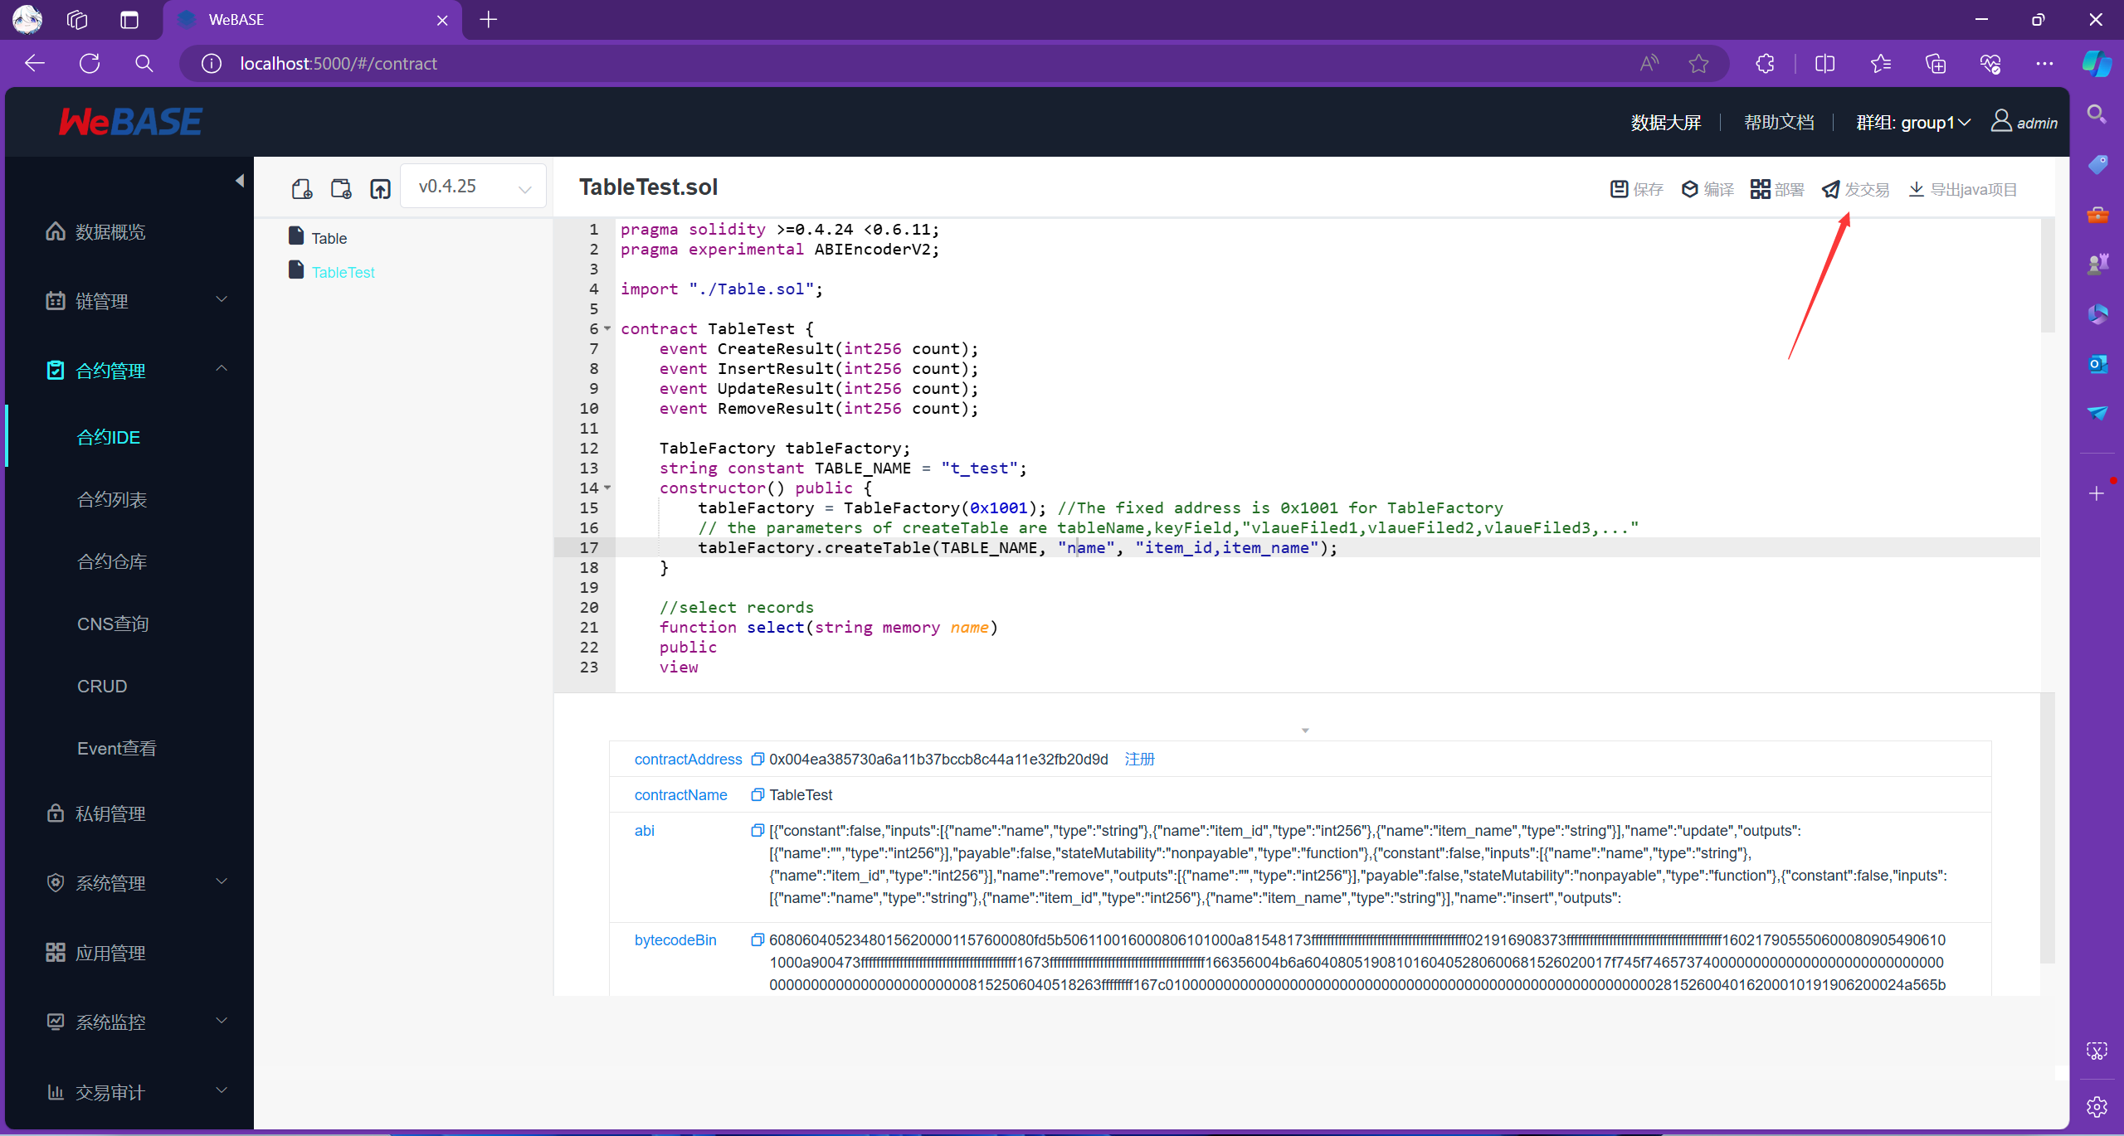

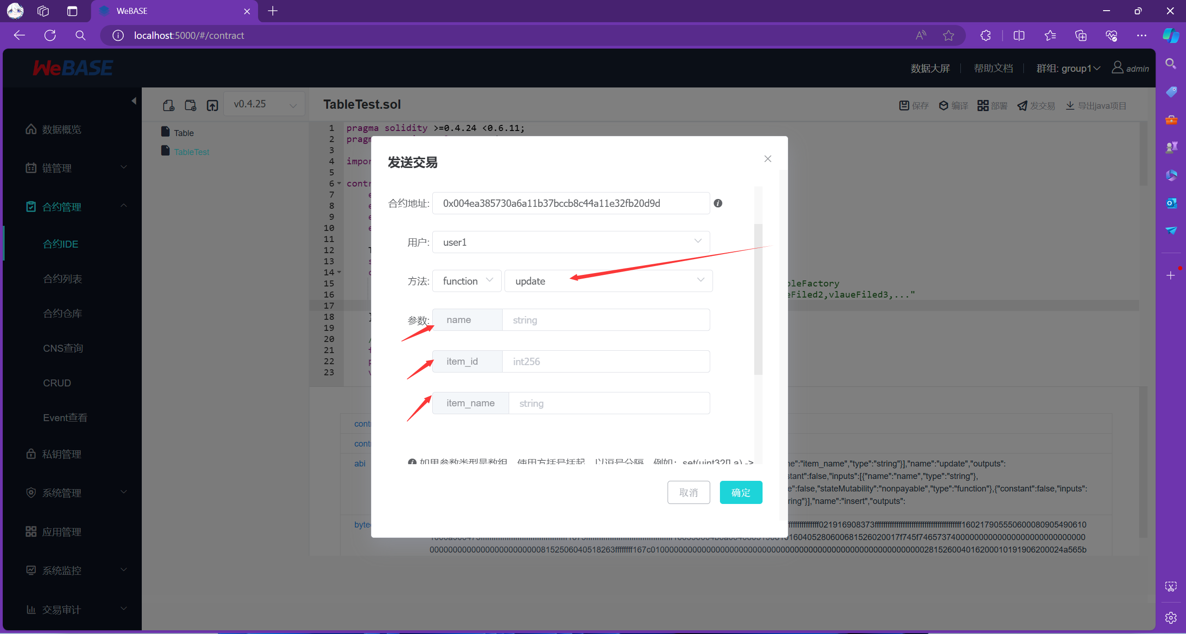

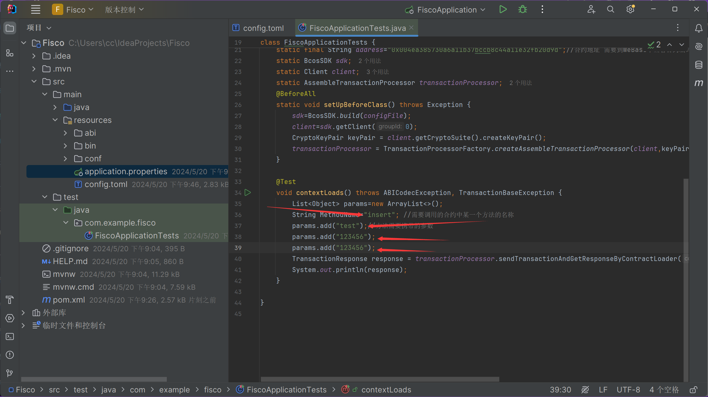

8）运行后端程序，并在WeBase中查看结果：

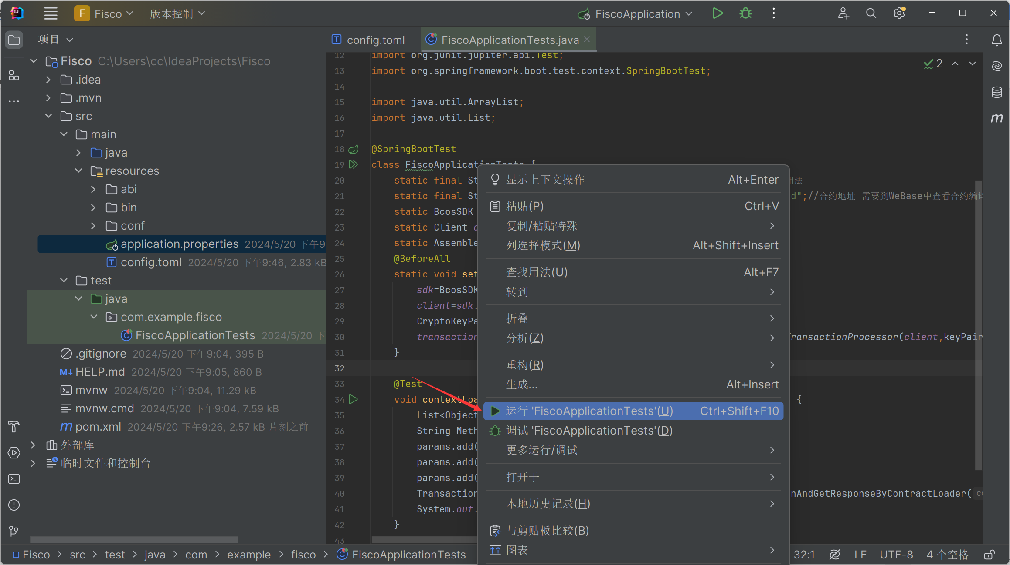

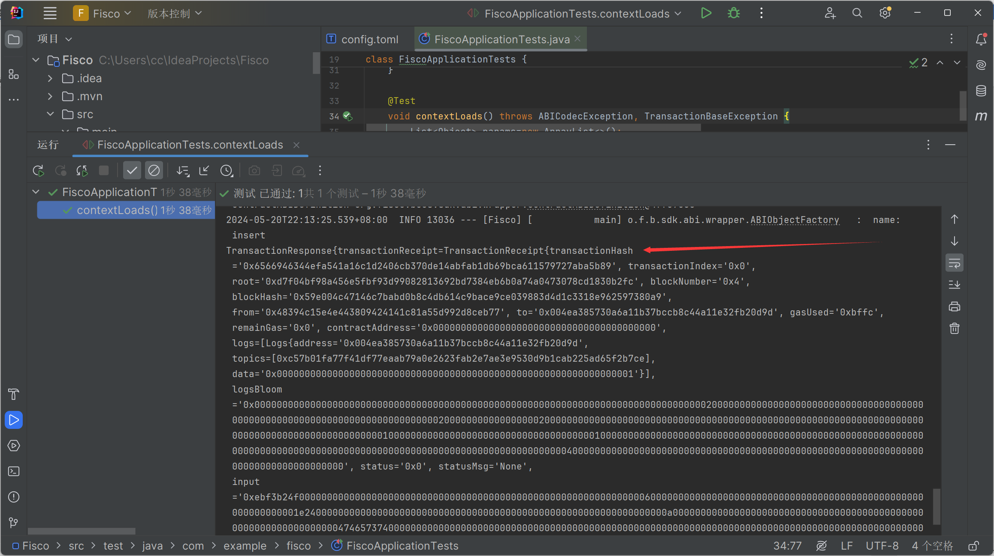

可以看到，交易回执已经成功打印出来了

因为使用insert方法插入了一条记录，我们可以在WeBase中使用发交易中的select方法来查看刚刚插入的记录（它需要一个参数作为查询的依据）：

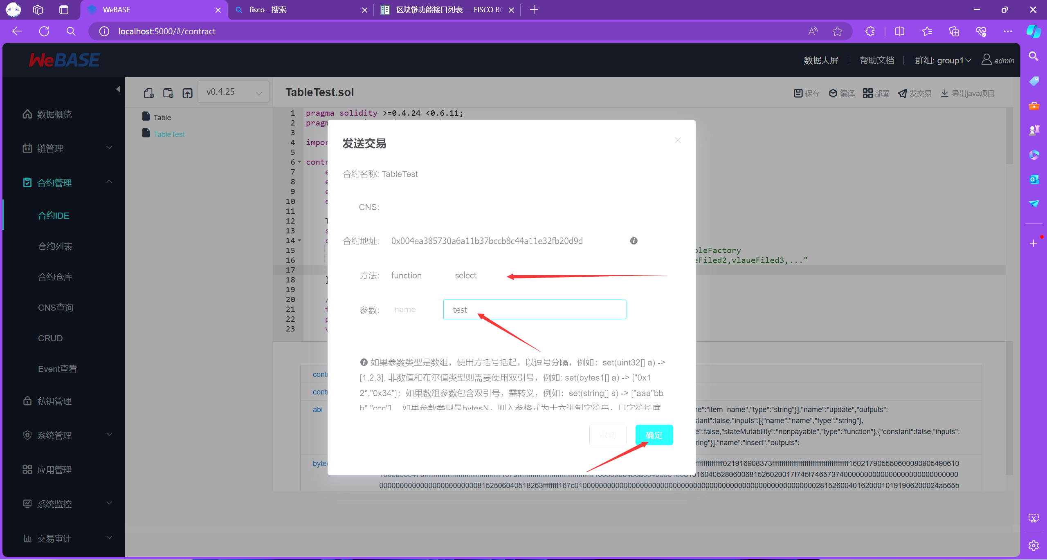

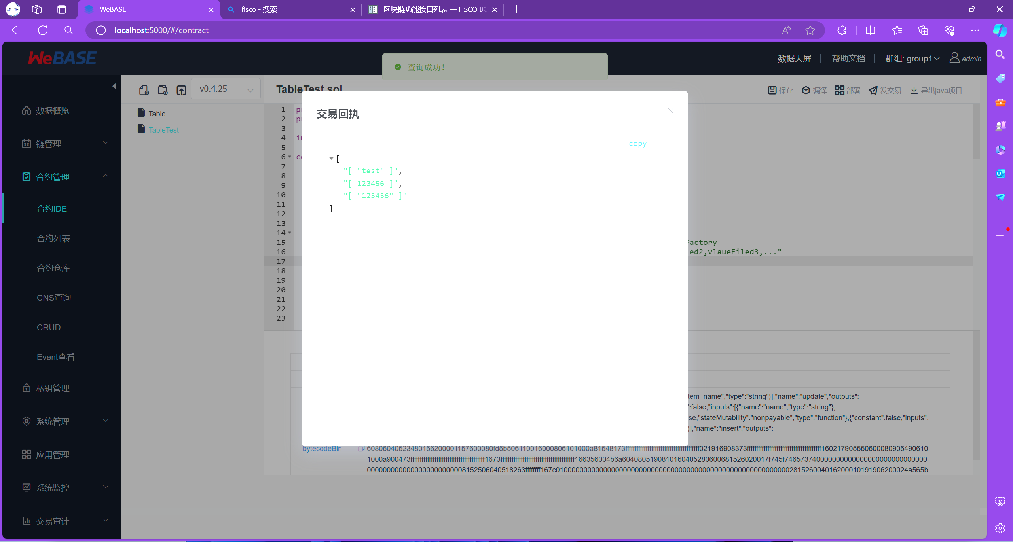

可以看到，数据已经成功的插入到了区块链中

到此，基础的后端程序与Fisco区块链的交互就已经完成了

更多的内容可以查阅官方的JavaSDK文档，还有很多不同功能的方法可以选择：

[Java SDK — FISCO BCOS 2.0 v2.9.0 文档 (fisco-bcos-documentation.readthedocs.io)](https://fisco-bcos-documentation.readthedocs.io/zh-cn/latest/docs/sdk/java_sdk/index.html)

[区块链功能接口列表 — FISCO BCOS 2.0 v2.9.0 文档 (fisco-bcos-documentation.readthedocs.io)](https://fisco-bcos-documentation.readthedocs.io/zh-cn/latest/docs/api.html)